--------------------------------X---------------------------------------

**What are the main Objective of Miroservice architecture**?

Ans-

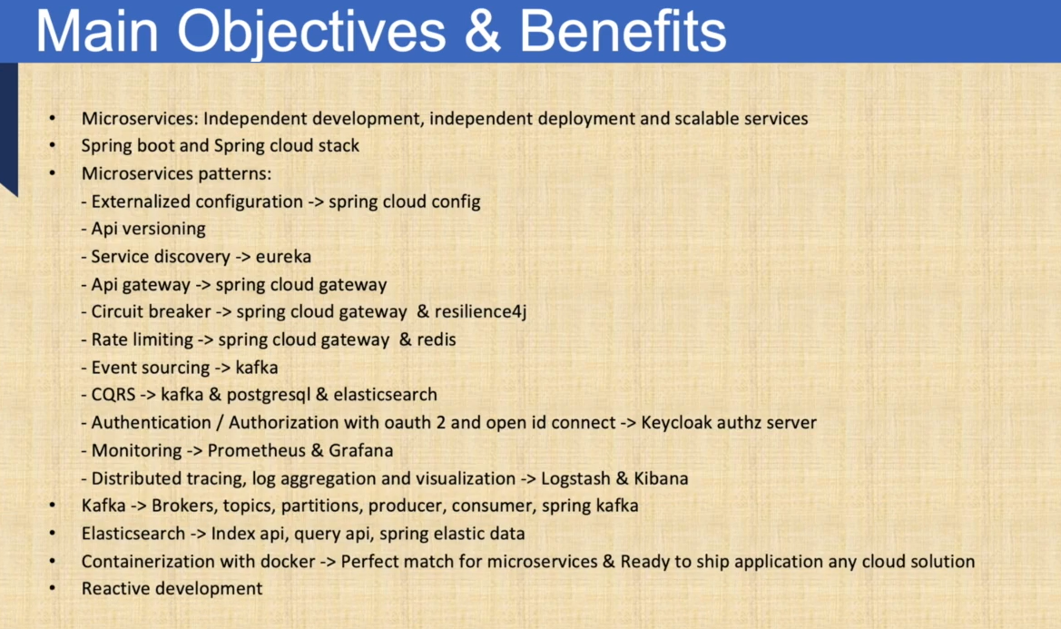

-----------------------------------X-------------------------------------------------------------

What is Monolithic?

Ans-

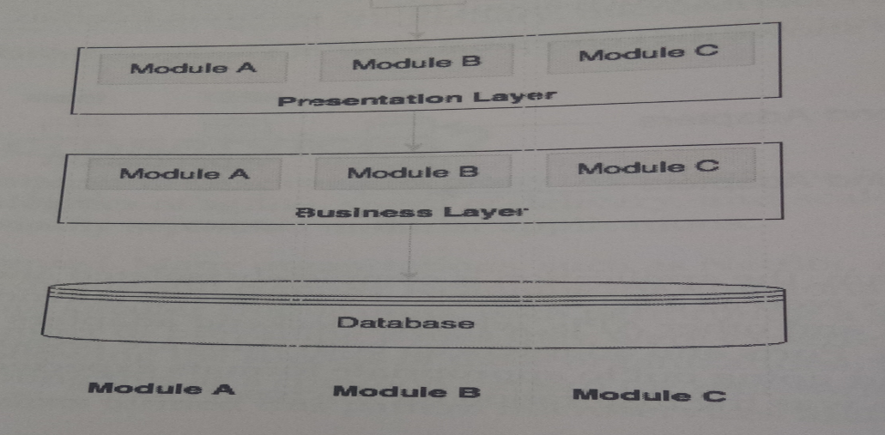

**--------------------------------------X---------------------------**

**What is Status que with monolithic applications?**

**----------------------X----------------------------**

**What is Miroservice?**

**Ans-**

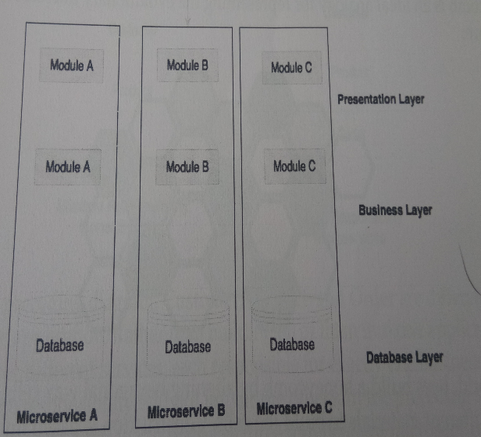

* Miroservice are an architectural pattern that structures an application as a collection of small, loosely coupled services that operate together to achieve a common goal.
* Because they work independently, they can be added, removed, or upgraded without interfering with other applications.
* It is popular architectural pattern next to SOA. And it is complemented by Devops and cloud

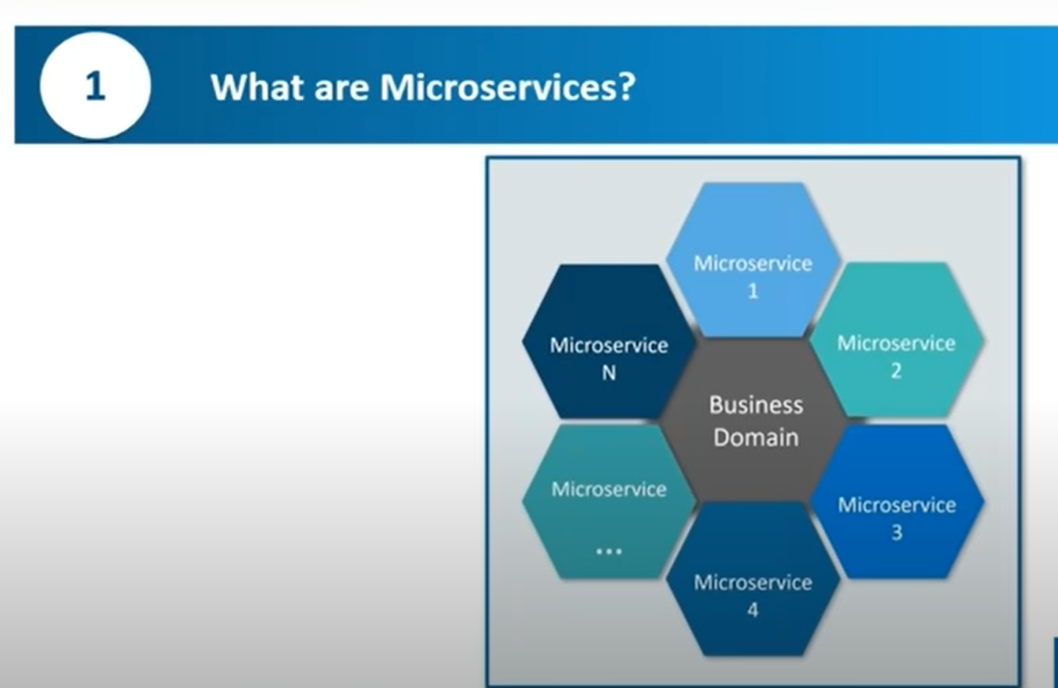

**What are advantages /Disadvantages of miroservice?**

**Ans-**Advantages/Disadvantages

* While there are numerous benefits to micro services architecture, like **easier deployment** and **testing**, **improved productivity**, **flexibility**, and **scalability**
* **A**s team structure, continuous delivery, deployment, and testing and decoupling, separation of concerns, agility.
* It promises agility, speed of delivery, as compared to traditional monolithic application
* Gone are the days where business invested in large application development with an around time of few years

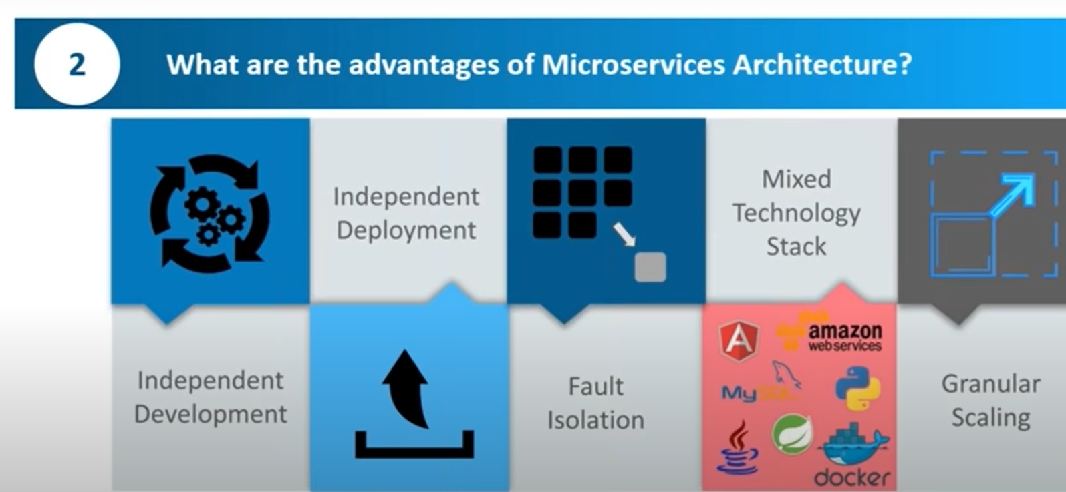

-------------------------------------------------X-------------------------------

**What are miroservice disadvantages?**

**Ans-** Disadvantage is as an independently run micro services require a seamless method of communication to operate as one larger application.

-----------------------------------------------X---------------------------------------------------

**What are the features of Miroservice?**

Ans-

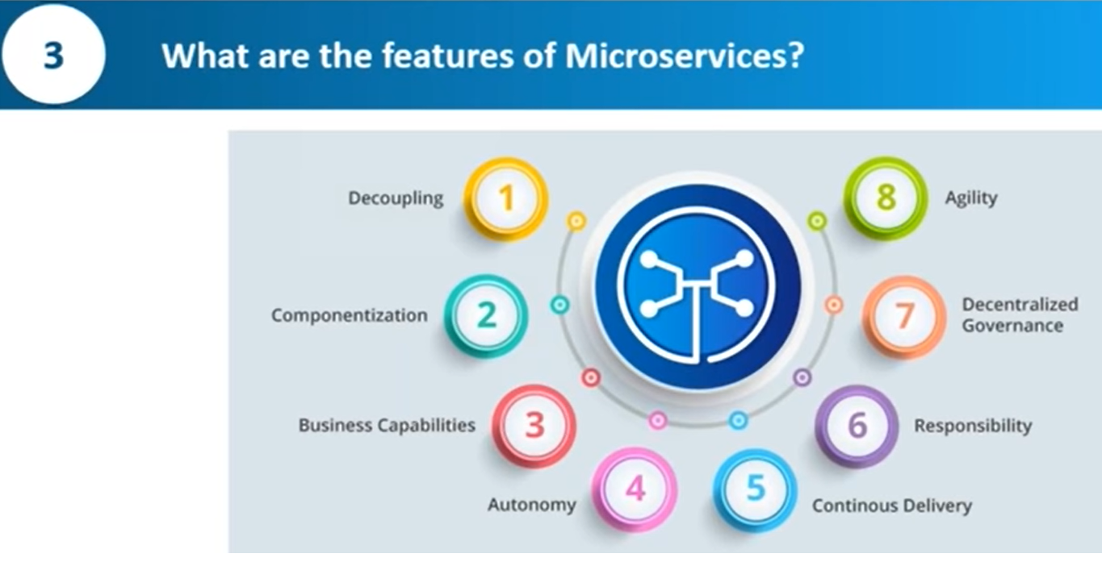

**---------------------------------------------------------------X-------------------------------------------**

**What are the characteristics of miroservice?**

**And-**

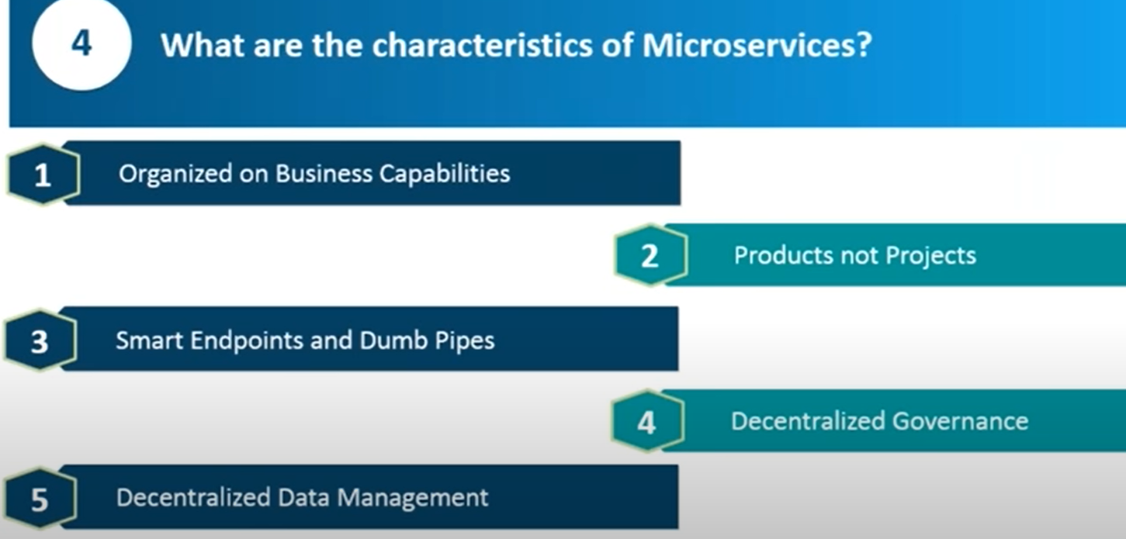

**-since individual micro services - autonomous DB-gives complete decentralize structure.**

**-small cluster of team building and maintaining the miroservice**

**-decentralize data management**

**--------------------------------------X--------------------------------------**

**What are the best practices to design the micro services?**

**Ans-**

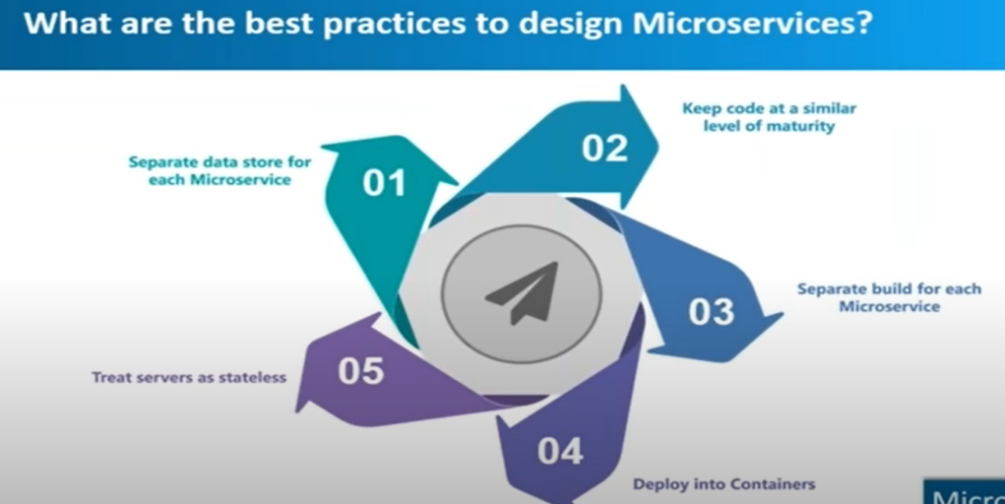

**------------------------------------------------X---------------------------------------------------**

**What Is DDD?**

**Ans-**

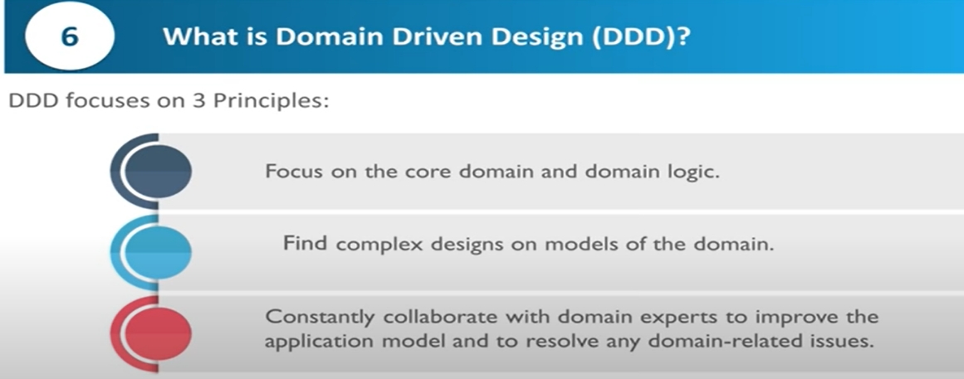

* Firstly, we should define principles to divide our code. As explained briefly already, hexagonal architecture defines **the inside and the outside part**.
* Controller-Application Layer
* Service-Domain layer
* Repository- Infrastructure

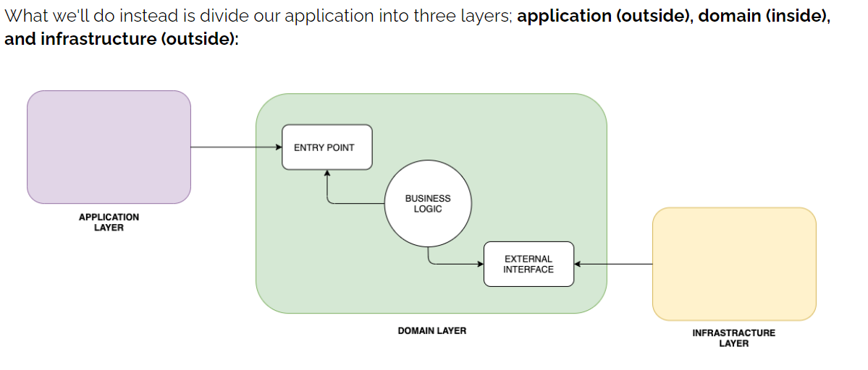

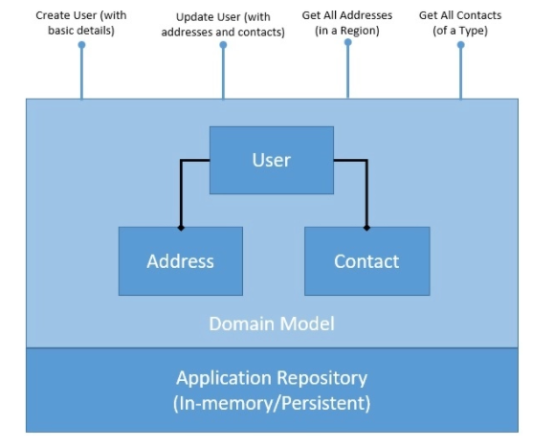

**----------------------------------------X------------------------------------------------------**

**What is Ubiquitous language?**

**Answer-**

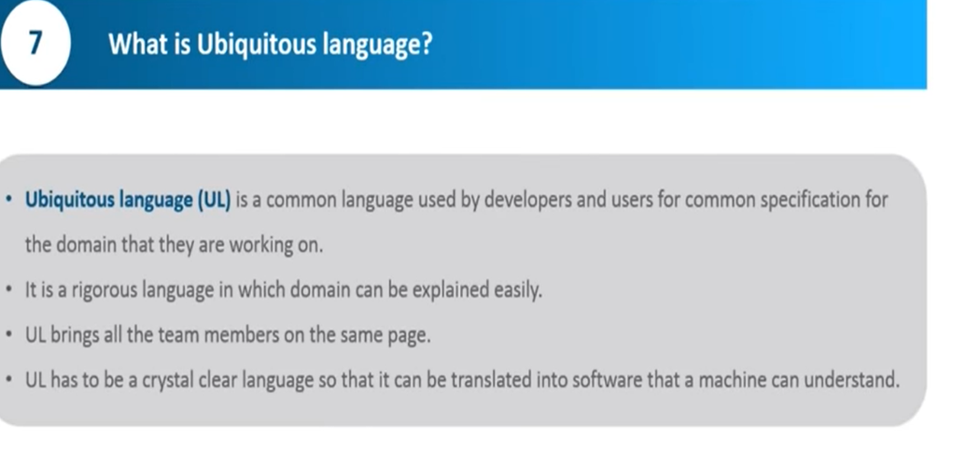

**-----------------------------------------------------X--------------------------------------------------**

**Why there is a need of DDD?**

**Ans-**

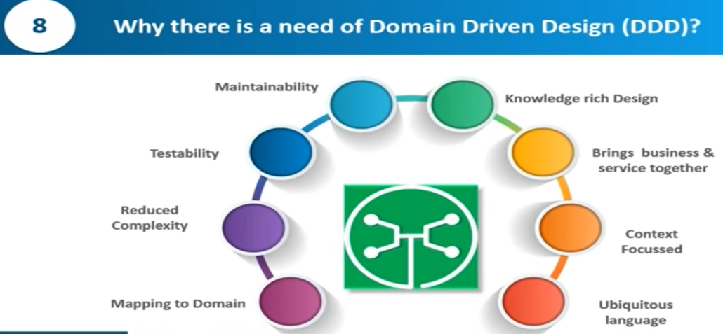

**--------------------------------------X------------------------------------------------------------------**

**How does miroservice architecture work?**

**Ans-**

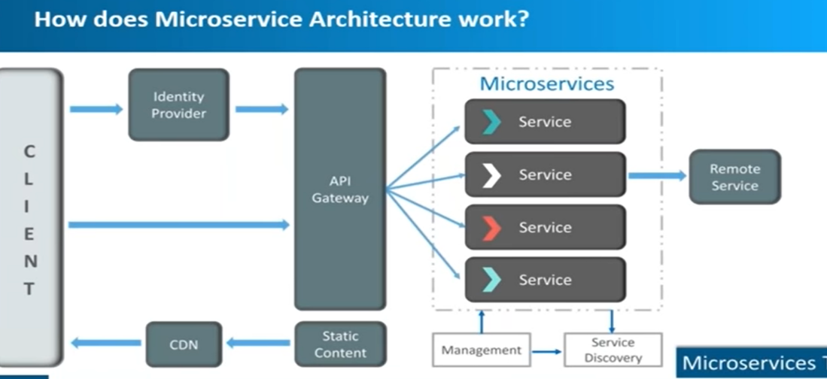

**--------------------------------------------------------------------------X----------------------------------------------------------**

**What are the pros and cons of miroservice?**

**Ans-**

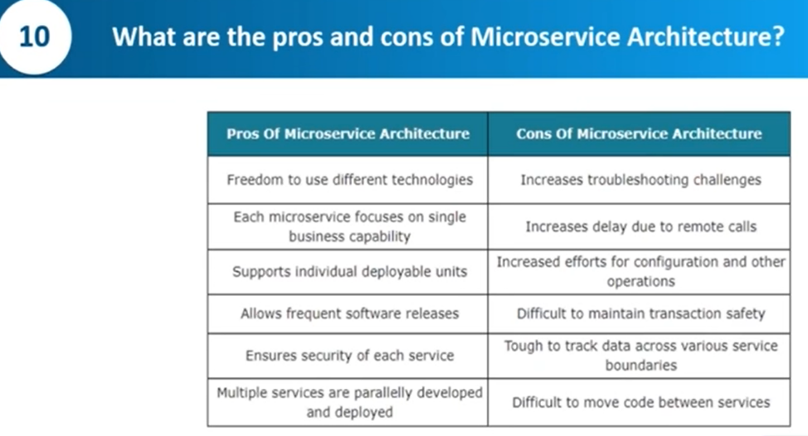

**----------------------------------------------------------------X--------------------------------------------**

**What is the difference between Monolithic, SOA, and miroservice?**

**Ans-**

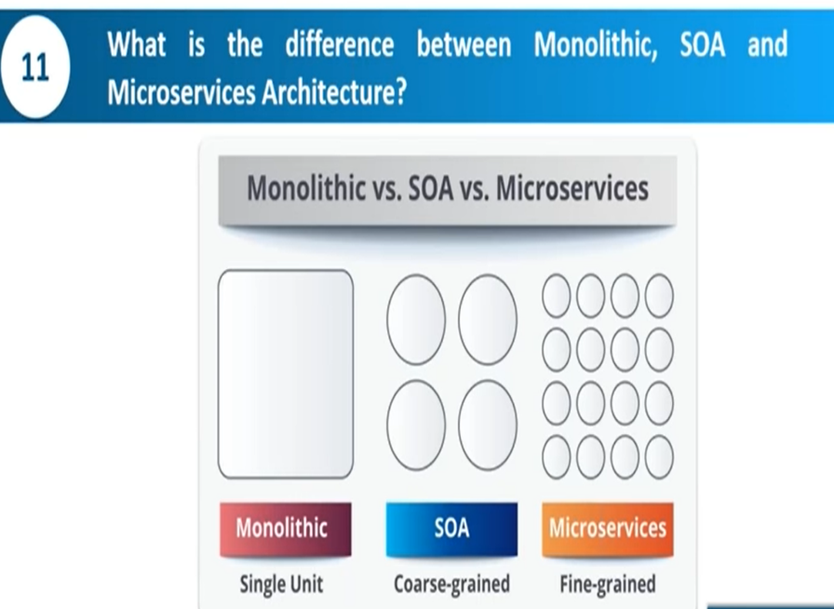

**SOA do not have complete modularity-**

**-------------------------------------------------------X------------------------------------------------------------------**

**What is the difference between SOA and Miroservice?**

**Ans-**

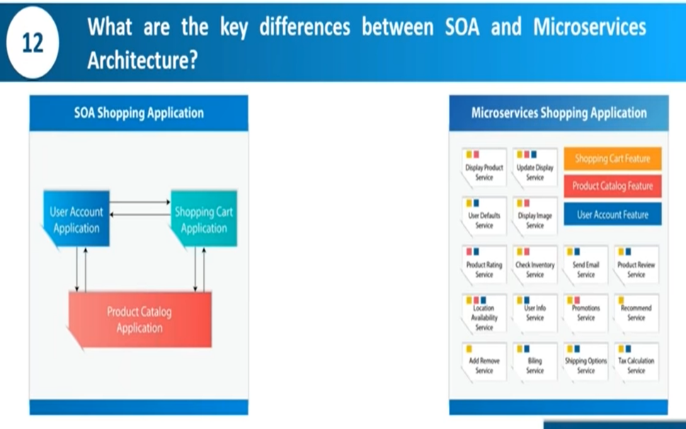

* **In SOA you need middleware for communication in miroservice not-.**
* **Miroservice communicate through rest api**

**----------------------------------------------------------------X----------------------------------------------**

**What are the challenges of miroservice?**

**Ans**

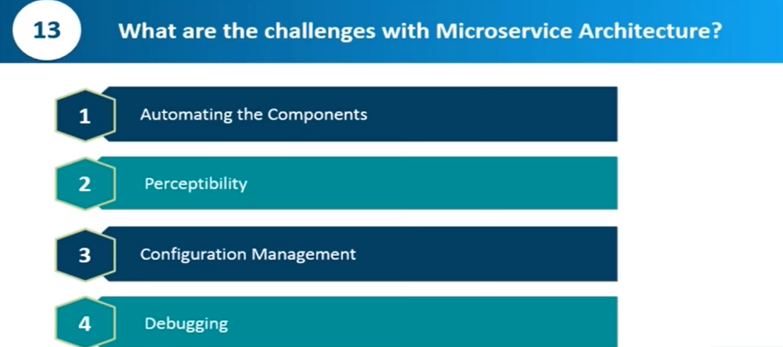

**-----------------------------------------X----------------------------------**

**What is cohesion?**

**Ans-**

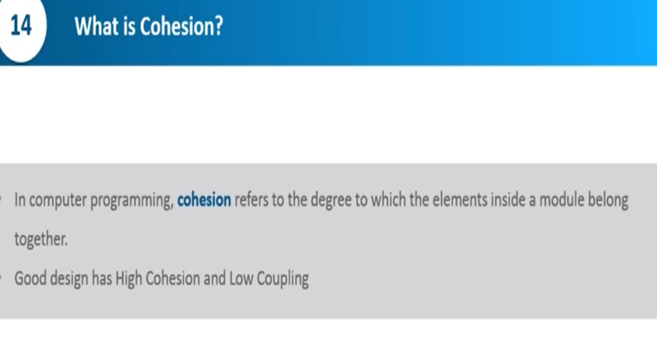

**-------------------------------------------------------------------X-------------------------------**

**What is Rest?**

**Ans-**

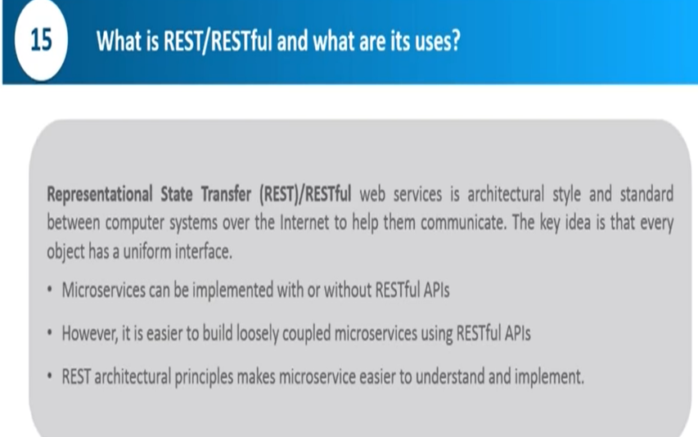

**------------------------------------------------------------X------------------------------------------------**

**What si Actuator?**

**Ans-**

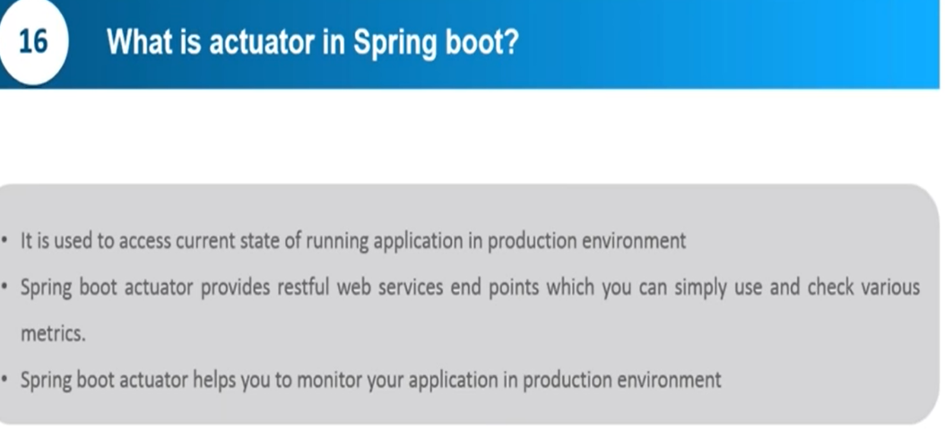

**--------------------------------------------------------X-------------------------------------------------------**

**What is Spring Cloud?**

**Ans-**

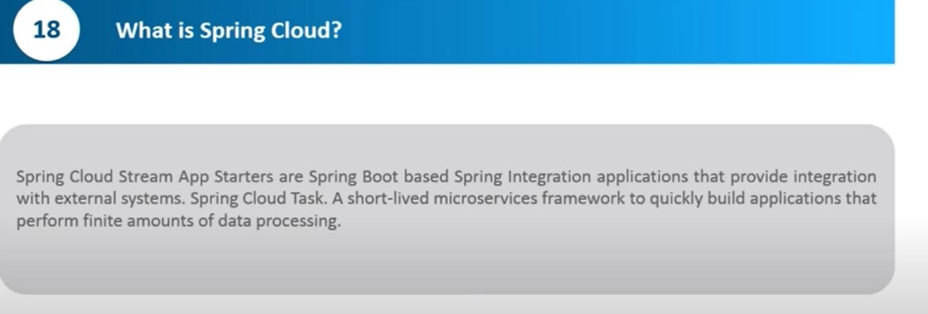

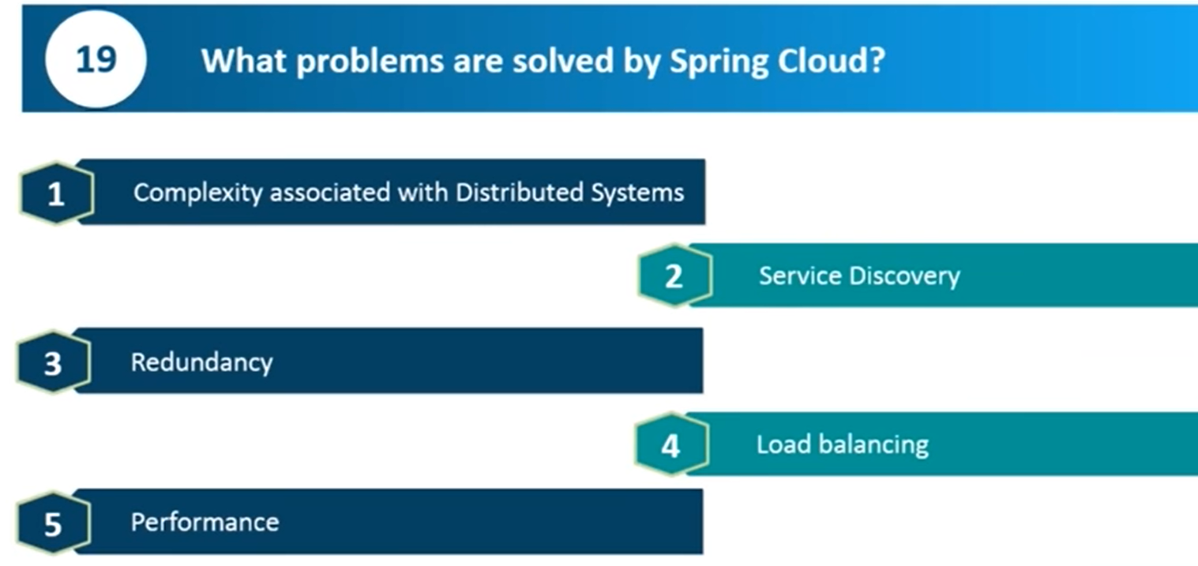

**--------------------------------------------------------------------X------------------------------------------------**

**What is the difference between Rest and Miroservice?**

**Ans-**

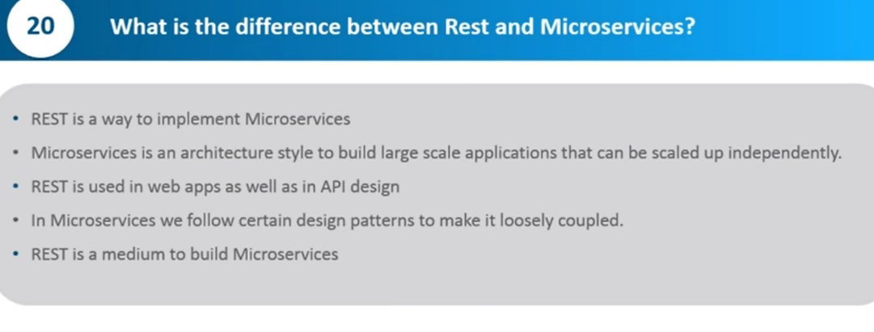

**--------------------------------------------------------X---------------------------------------------**

**What are different testing for Miroservice?**

**Ans-**

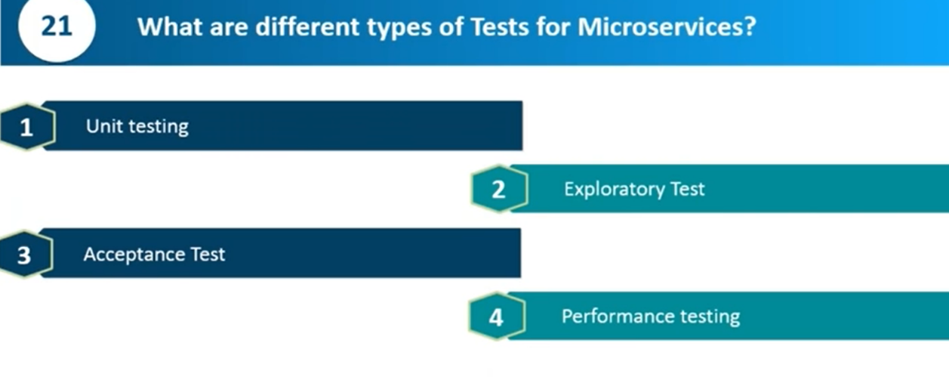

**----------------------------------------------------------------X------------------------------------**

**What is distributed transaction?**

**Ans-**

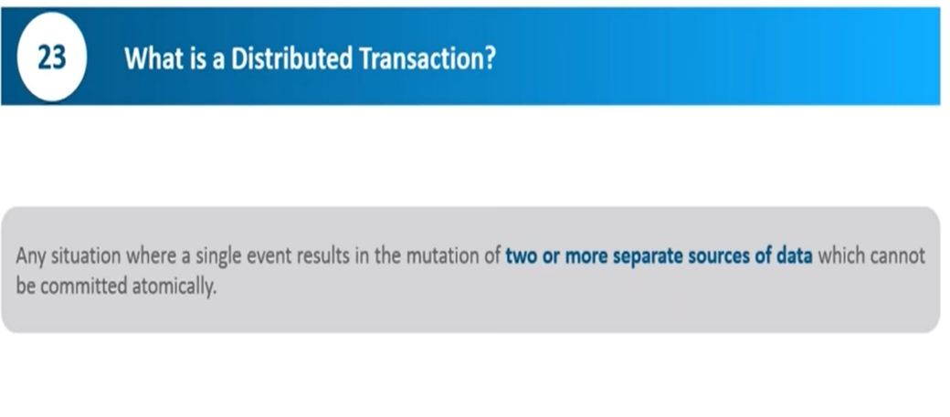

**------------------------------------------------------------X--------------------------**

**What is idempotence?**

**Ans-**

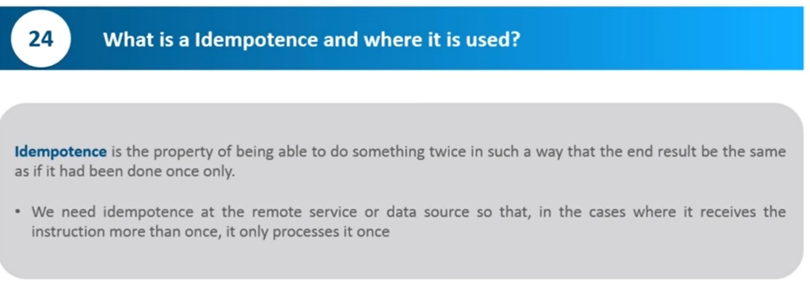

**-----------------------------------------------------------X-----------------------------------**

**What is bounded Context?**

**Ans-**

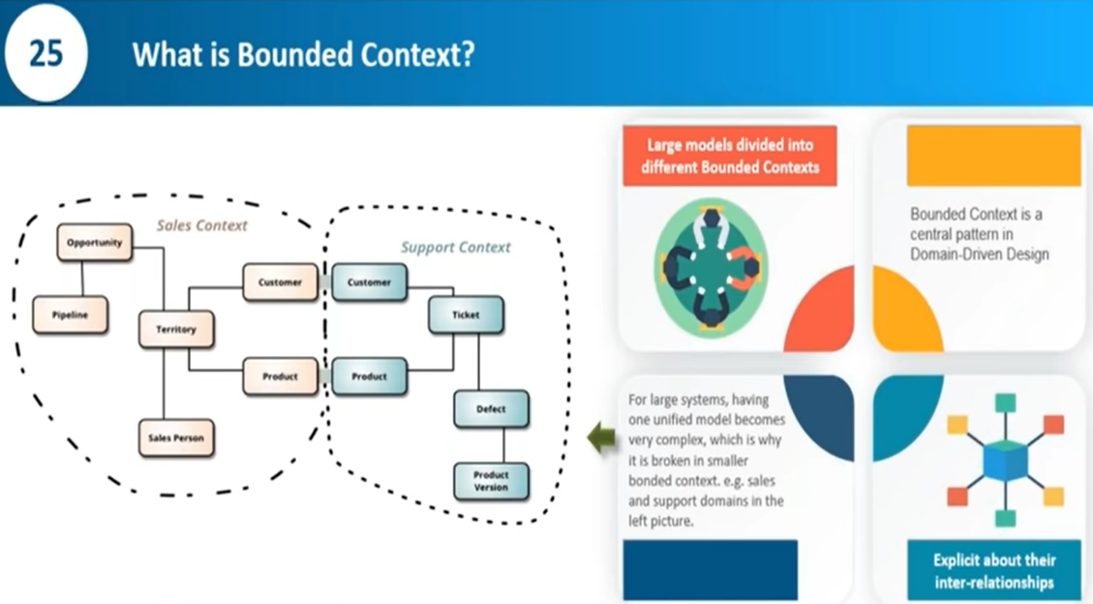

* First let’s understand the meaning of the word context. Context means “a set of facts the surround a language, circumstance or event that determines it’s interpretation”. This means that the same entity could be interpreted differently depending on the specific concept.
* So we can now understand the term bounded context as “the boundary within with an entity made certain sense”.

With respect to bounded context, a book can be any of the following:

* something written by an author and with a title
* an item sold by a seller (from the concept of the seller)
* just an item in the cart (from the context of a shopping cart)
* goods dispatched by a courier
* and so on

While we are describing the same entity, we want to ensure that they are not tied together in any way. This would be in line with the principle of loose-coupling in microservices.

Now bounded-context closely relates to Domain-Driven-Design(DDD). DDD is explained in another article. This is where an application is partitioned into services where each aligns with a particular business domain.

According to [Vadim Samokhin](https://codeburst.io/@wrong.about), bounded context is a logical boundary. It defines **some tangible boundary between sub-domains**. He came up with three different perspectives for bounded contexts:

**domain expert perspective**: It is the bounds within which certain business processes are implemented and certain terms/languages are applied.

**software developer perspective**: the way models are designed around certain sub-domain. For example, from identity management perspective, a person would be defined as a user with certain roles/privileges while from an organization’s HR perspective, a person is modeled as an employee.

**run-time perspective**: bounded context represents logical boundaries which is defined by contract of service where the model is implemented.

**----------------------------------------------------------------X---------------------------------------------------------**

**What is 2 factor authentication?**

**Ans-**

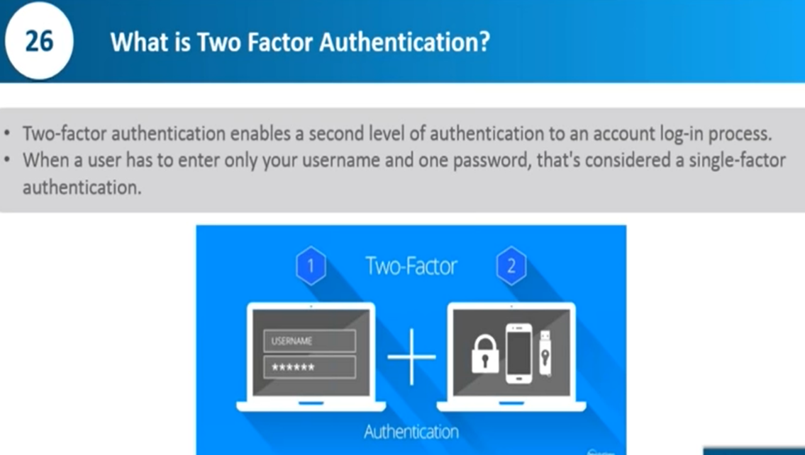

**------------------------------------------------------------X--------------------------------------------**

**What is client certificate?**

**Ans-**

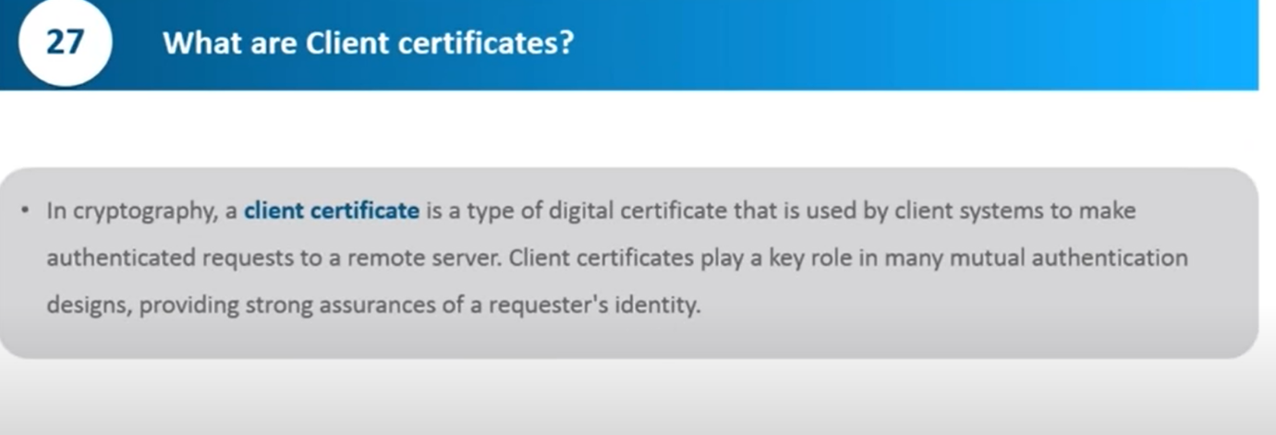

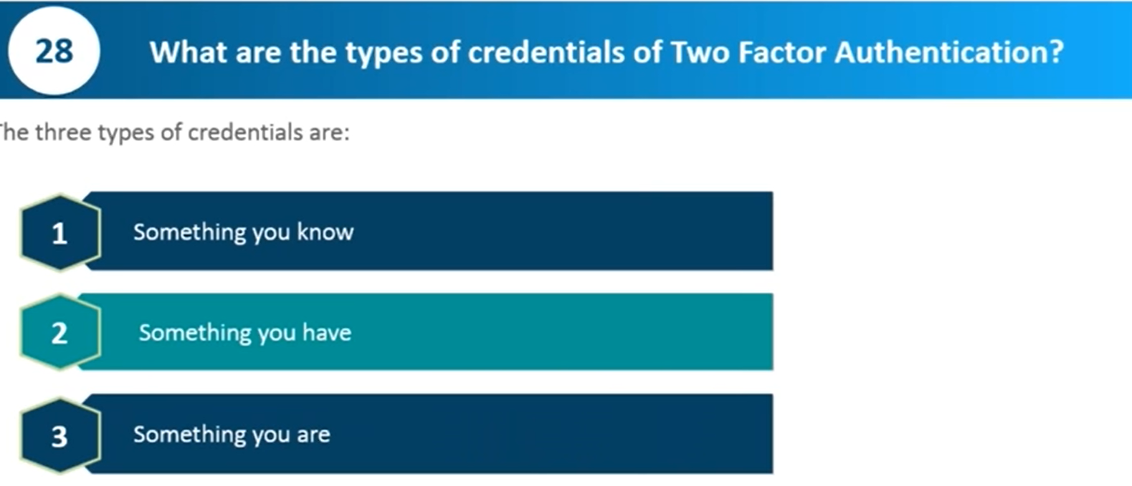

**-------------------------------------------------------------X----------------------------------------------------**

**What is PACT?**

**Ans-**

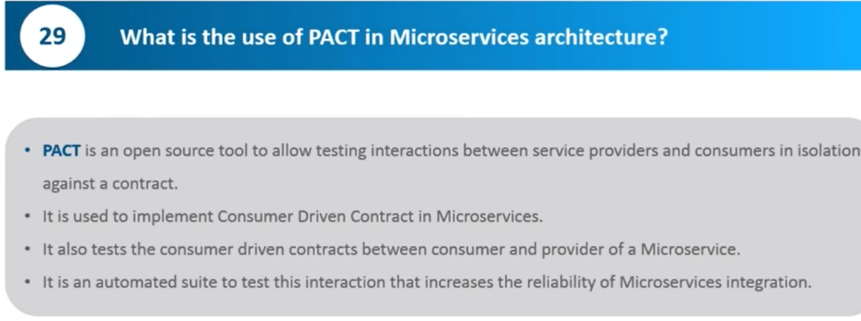

**-----------------------------------------------------------X--------------------------------**

**What is Oauth?**

**Ans-**

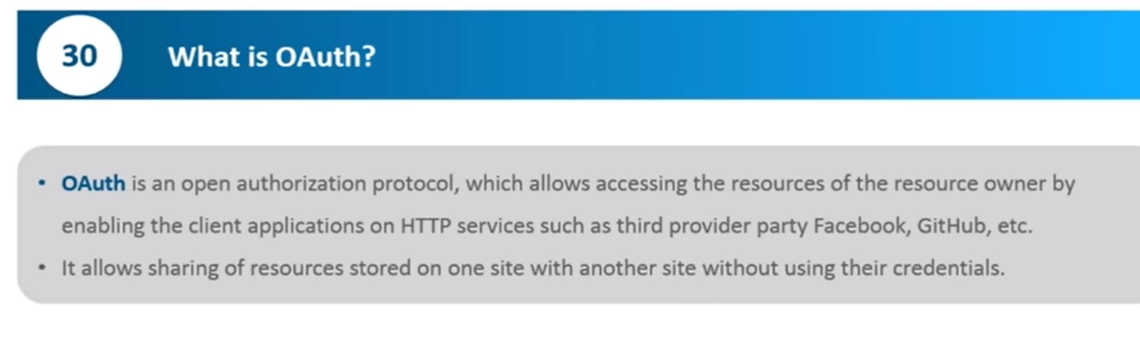

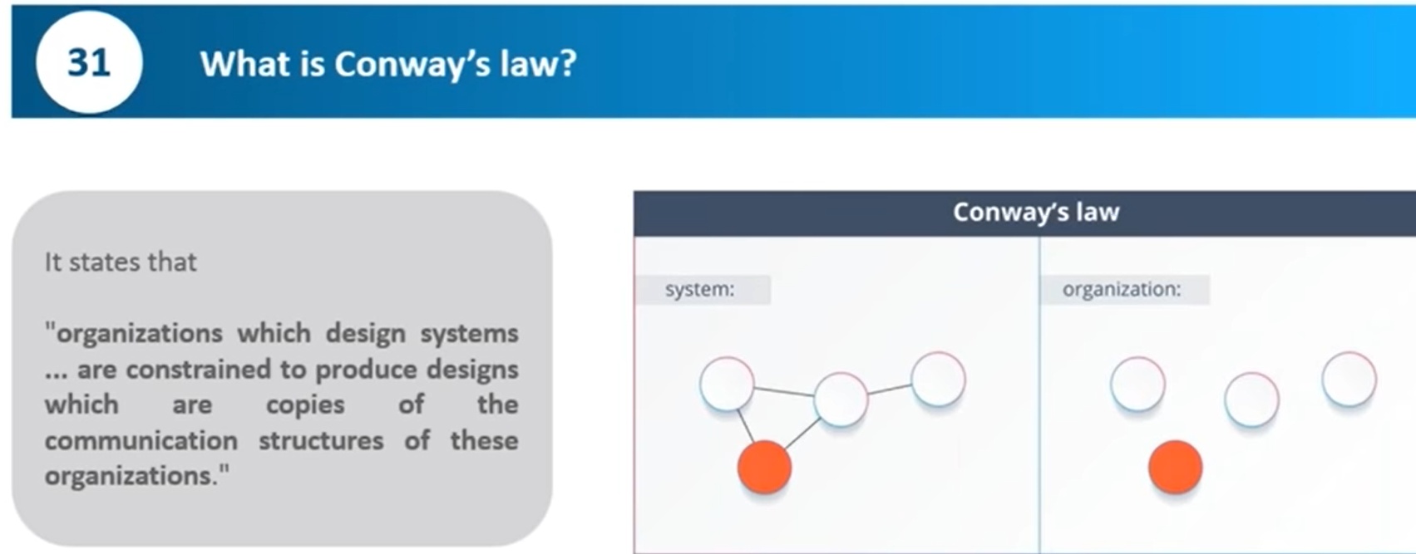

**----------------------------------------------X-------------------------------------------------**

**What is contract testing?**

**Ans-**

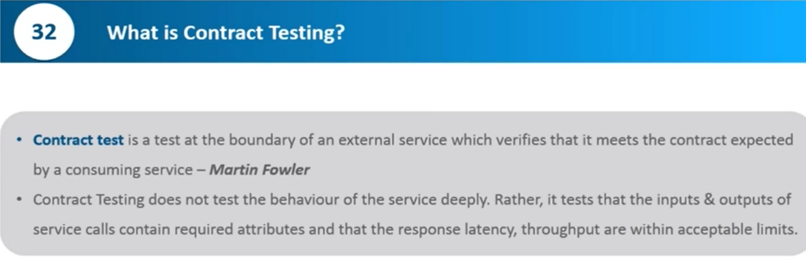

**----------------------------------------------------X--------------------------------**

**What is purpose of Docker?**

**Ans-**

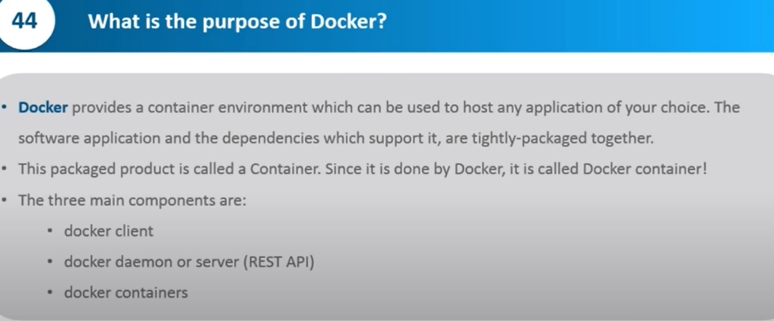

**-----------------------------------------------------------X-------------------------------------------------------------------------**

**What is Lombok?**

**Ans-** Project **Lombok** is a Java library tool that generates code for minimizing boilerplate code. The library replaces boilerplate code with easy-to-use annotations.

**----------------------------------------------------------------X--------------------------------**

**What is Reactive Programming?**

**Ans-**

**Reactive programming** is a **programming** paradigm that promotes an asynchronous, non-blocking, event-driven approach to data processing.

**Reactive programming** involves modelling data and events as observable data streams and implementing data processing routines to react to the changes in those streams

**-----------------------------------------X---------------------------------------------------**

**What is Kafka?**

**Ans-**Kafka is an open source software which provides **a framework for storing, reading and analysing streaming data**.

Being open source means that it is essentially free to use and has a large network of users and developers who contribute towards updates, new features and offering support for new users.

**---------------------------------------------------------------X-------------------------------**

**What is Event Driven Architecture?**

**Ans-**

* Event-driven micro services allow for real-time micro services communication, enabling data to be consumed in the form of events before they’re even requested.

-------------------------------------------------------------X----------------------------------------------------------

**What is Event Streaming and Data?**

Ans-

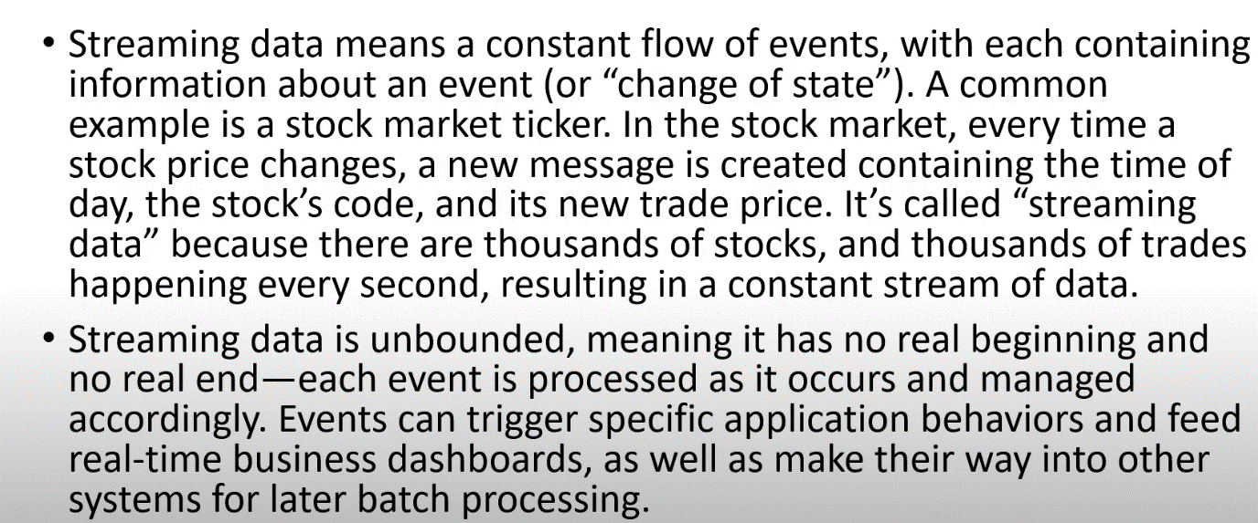

**----------------------------------------------------------------X-----------------------------------------------------**

**What is Kafka Server?**

Ans-

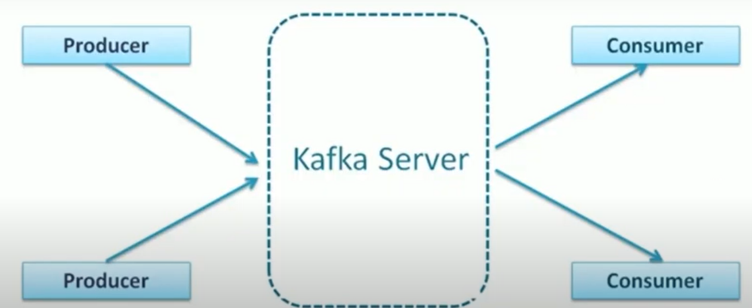

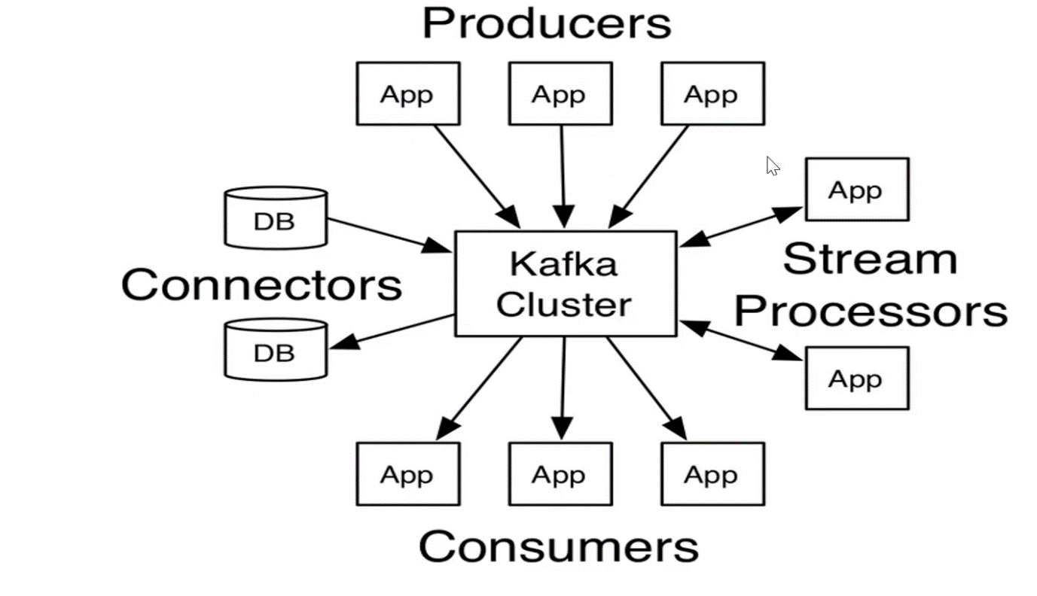

-----------------------------------------------X---------------------------------------------------

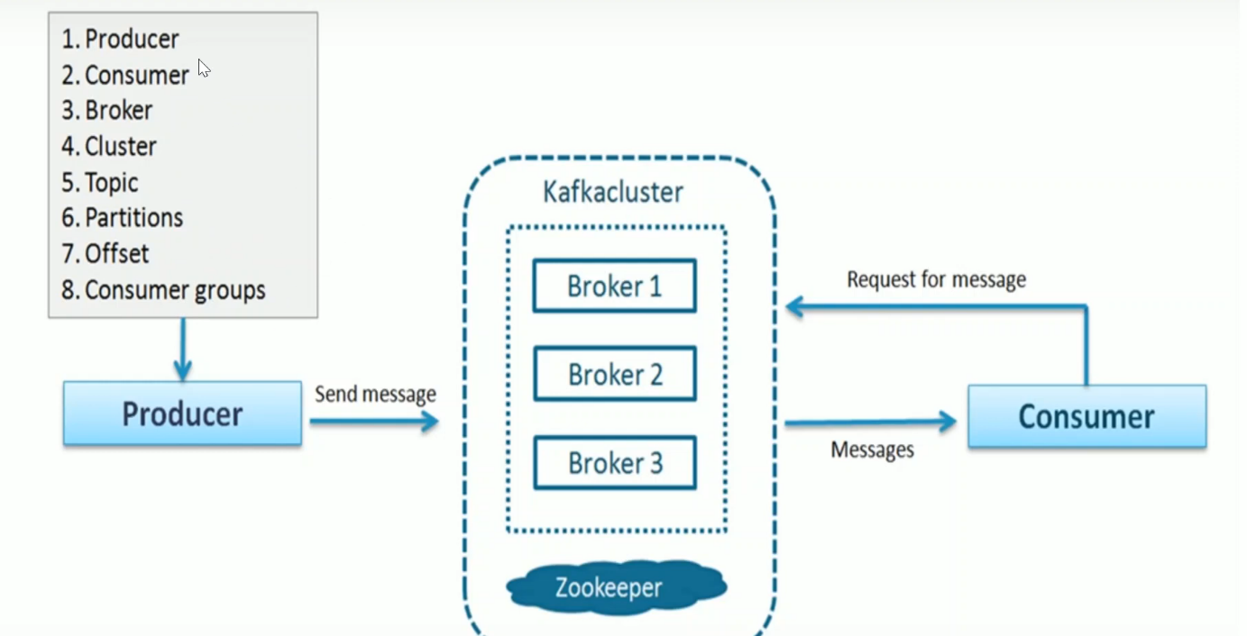

----------------------------X-------------------------------------

**What is Apache kafka?**

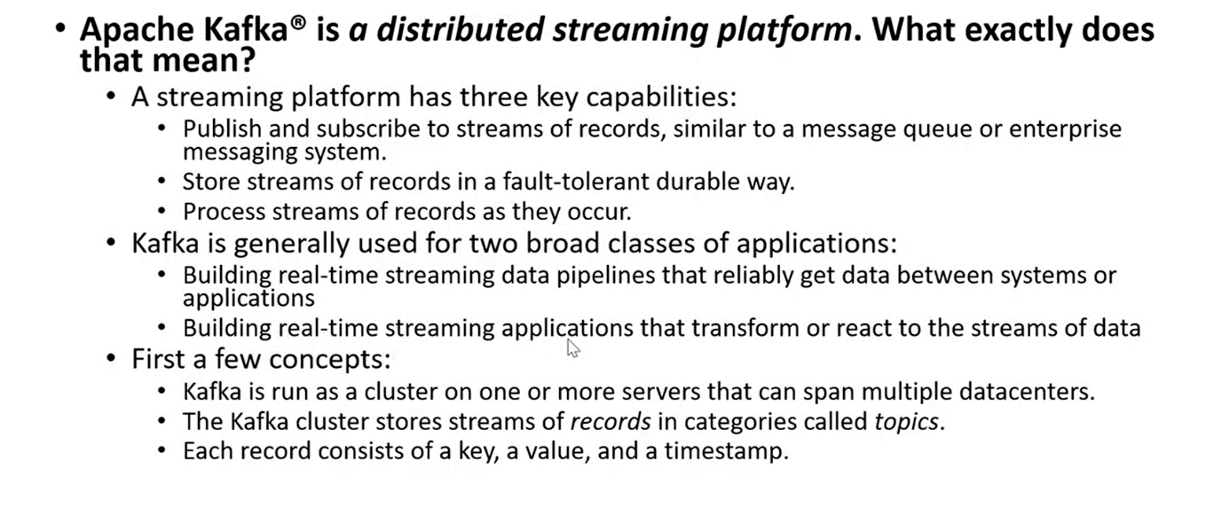

**----------------------------------------------------------X--------------------------------------------**

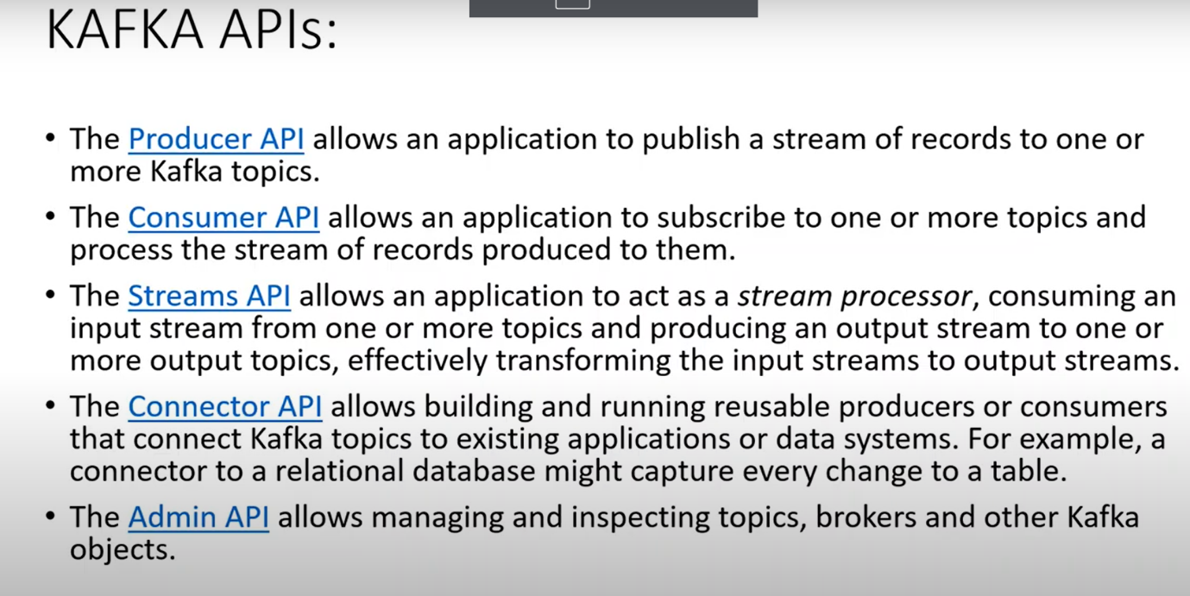

---------------------------------------------X------------------------------------------------------

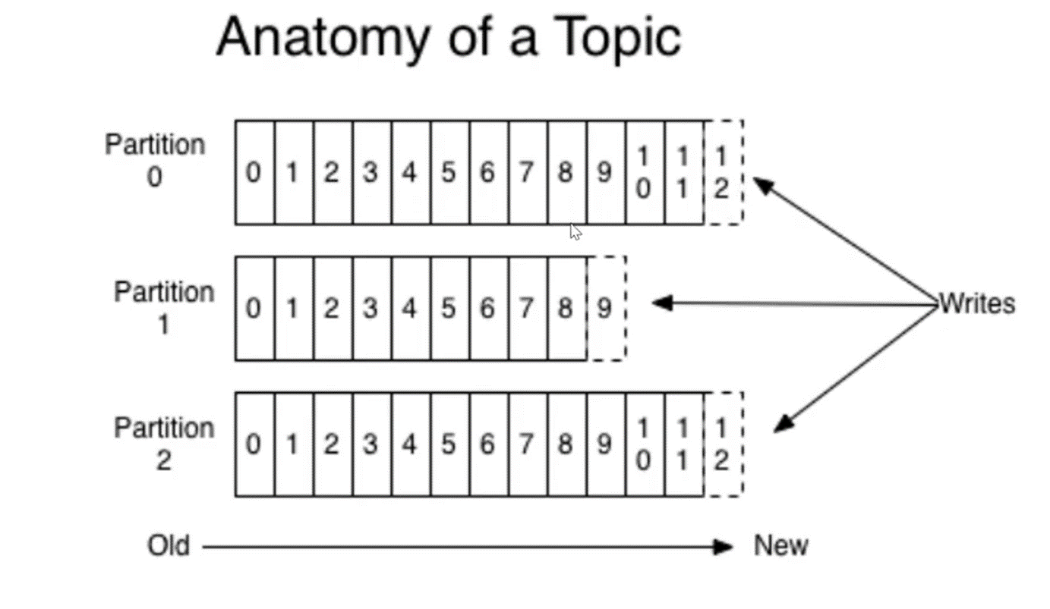

**--------------------------------------------X-----------------------------------------------**

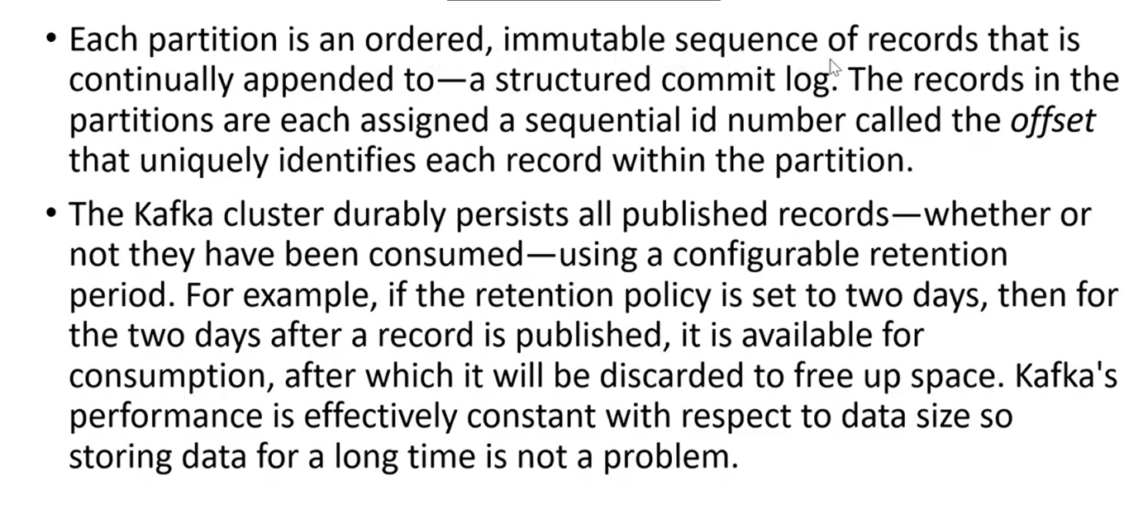

----------------------------------------------------------X------------------------------------------------------

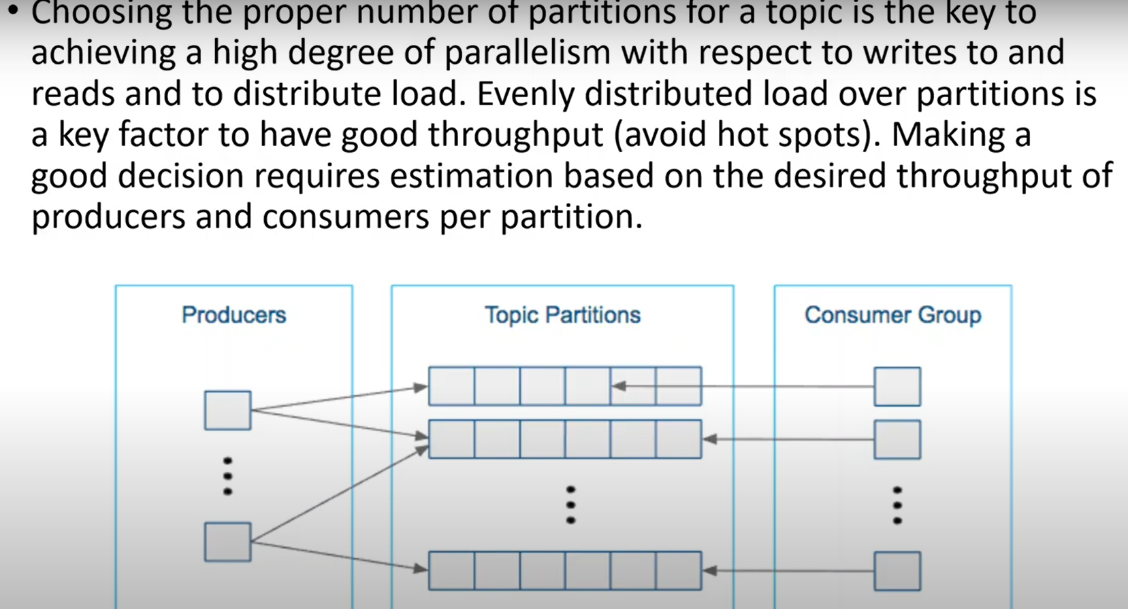

**------------------------------------X--------------------------------------------------------**

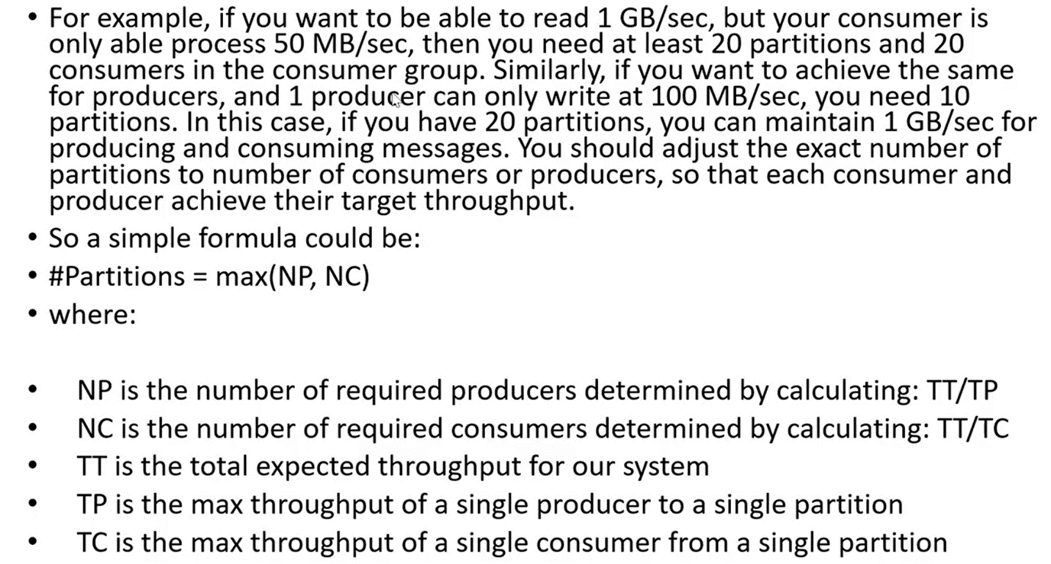

**-------------------------------------------------------X------------------------------------------------------------------**

**What is a difference between Rabbit and Kafka?**

Ans

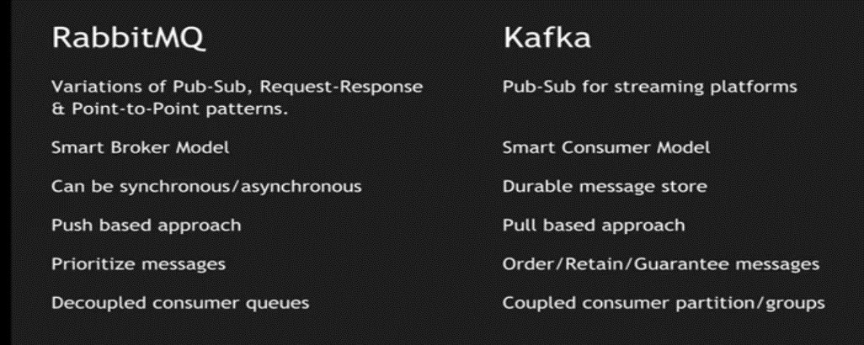

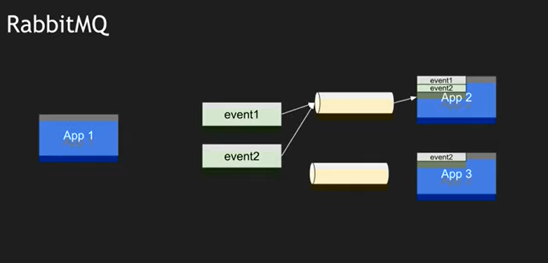

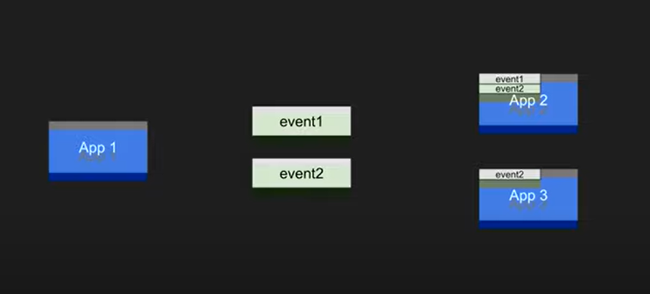

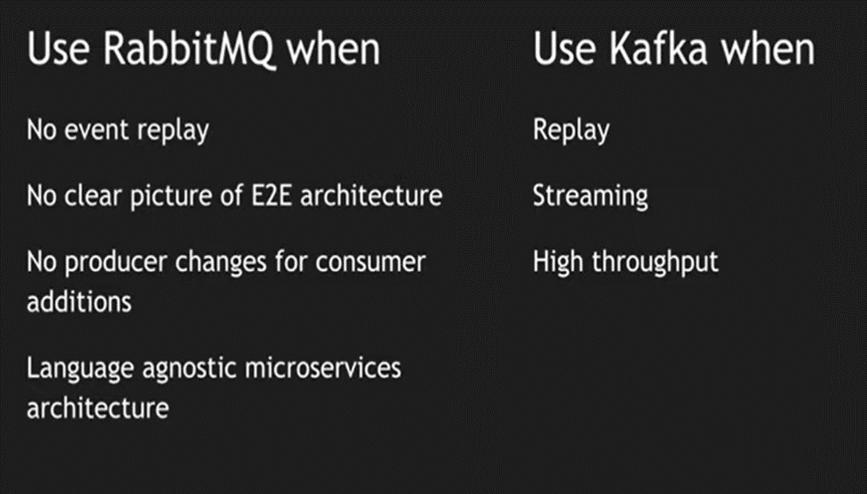

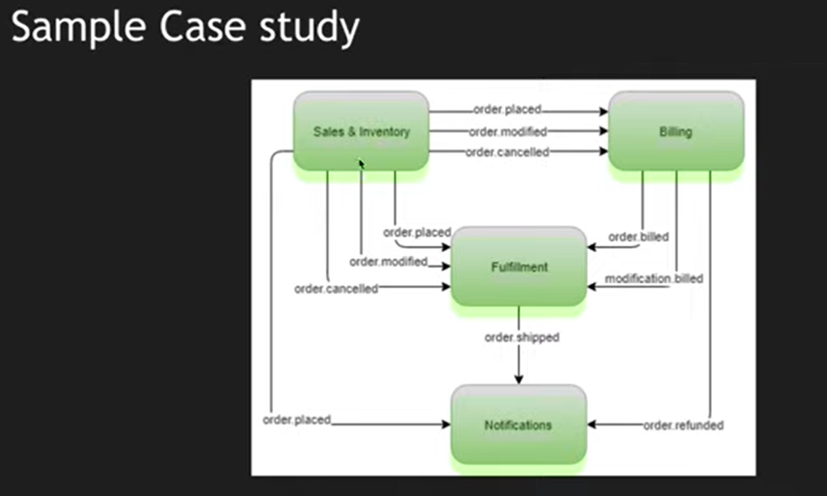

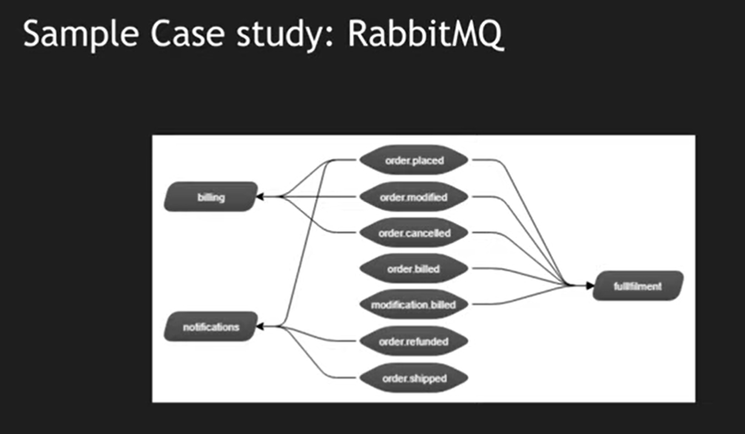

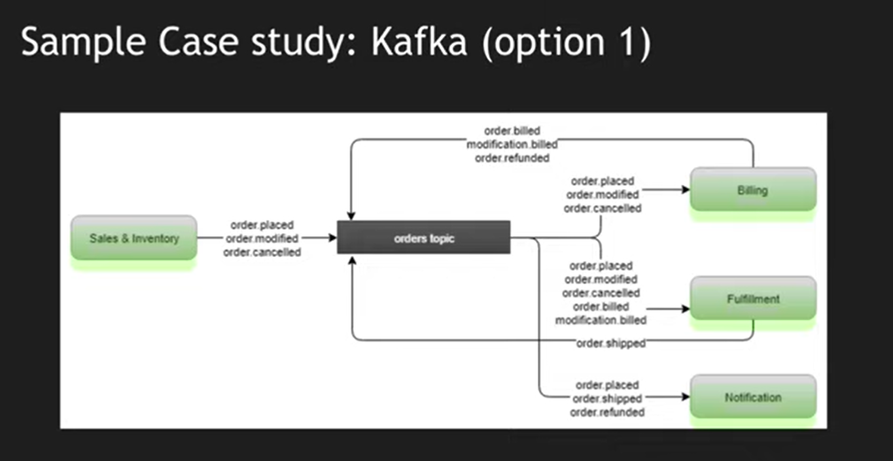

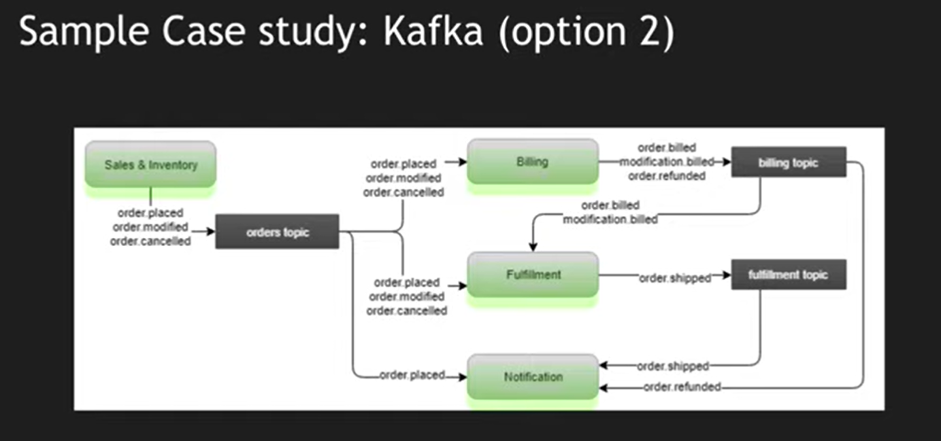

**---------------------------------------X---------------------------------------------------**

**What is Open API?**

Ans:-

* Renamed from the Swagger Specification to OpenAPI Specification in 2015.
* Traditional API Development and Documentation as follows. Following used to be communication with each other to check rest api work properly with all resources and business logic and there used to be technical writer who used to write the technical documentation

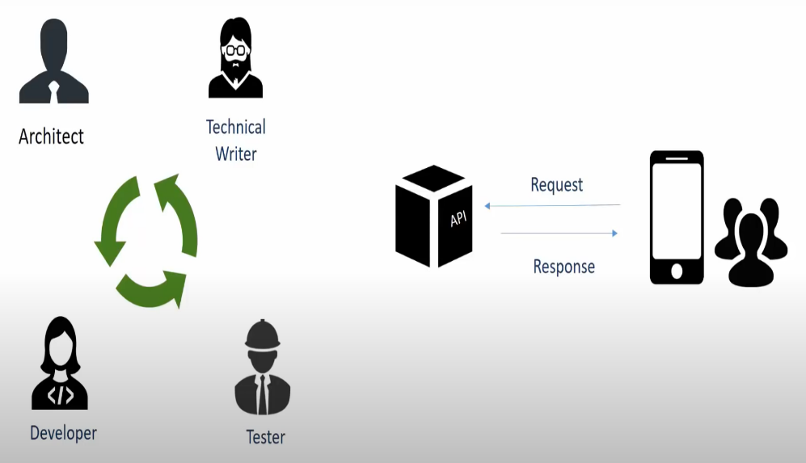

* Major problem with traditional approach. Because api keeps on updating. and no real designed define how thing work so no plan for building api. if services build in different language then we cannot restrict the service to consume from same language SDK.
* There should to be common framework. In 2010 worldneck created Restful interface.

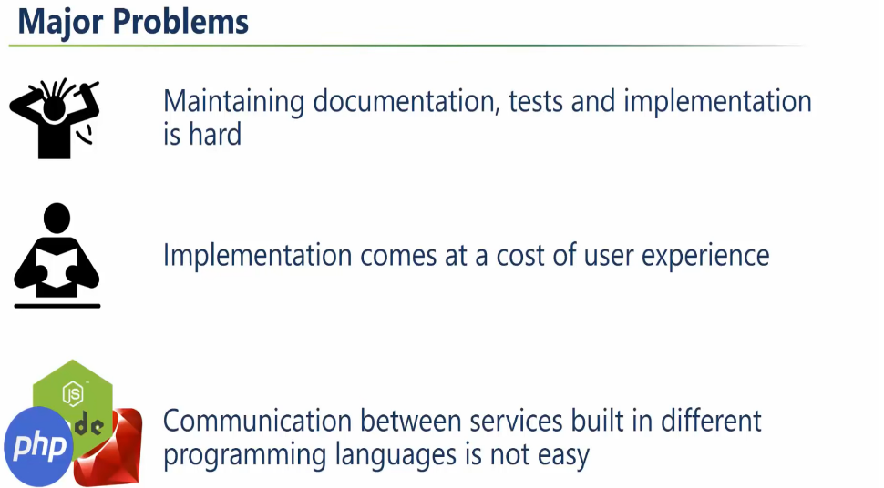

**-----------------------------------------------X----------------------------------------------**

**What is Restful API?**

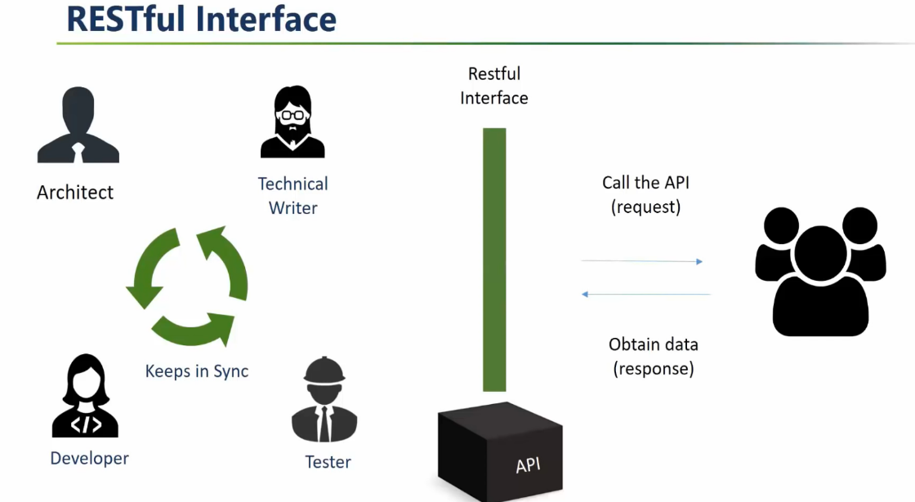

-------------------------------------------X------------------------------------------

### **What Is OpenAPI?**

**OpenAPI Specification** (formerly Swagger Specification) is an API description format for REST APIs. An OpenAPI file allows you to describe your entire API, including:

* Available endpoints (/users) and operations on each endpoint (GET /users, POST /users)
* Operation parameters Input and output for each operation
* Authentication methods
* Contact information, license, terms of use and other information.

API specifications can be written in YAML or JSON. The format is easy to learn and readable to both humans and machines

**------------------------------------------------------X------------------------------------------**

### **What Is Swagger?**

**Swagger** is a set of open-source tools built around the OpenAPI Specification that can help you design, build, document and consume REST APIs. The major Swagger tools include:

* [Swagger Editor](http://editor.swagger.io/) – browser-based editor where you can write OpenAPI specs.
* [Swagger UI](https://swagger.io/swagger-ui/) – renders OpenAPI specs as interactive API documentation.
* [Swagger Codegen](https://github.com/swagger-api/swagger-codegen) – generates server stubs and client libraries from an OpenAPI spec.
* Swagger is the bunch of tools with implementation of open api specification.

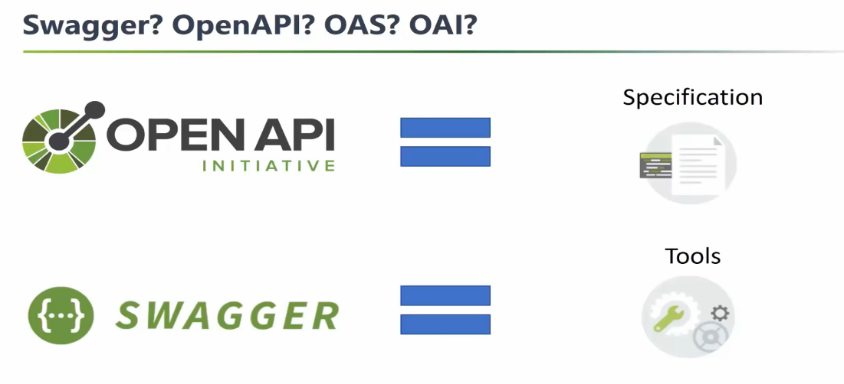

----------------------------------------X------------------------------------------------------------------------------

### **Why Use OpenAPI?**

The ability of APIs to describe their own structure is the root of all awesomeness in OpenAPI. Once written, an OpenAPI specification and Swagger tools can drive your API development further in various ways:

* Design-first users: use [Swagger Codegen](https://swagger.io/swagger-codegen/) to **generate a server stub** for your API. The only thing left is to implement the server logic – and your API is ready to go live!
* Use [Swagger Codegen](https://swagger.io/swagger-codegen/) to **generate client libraries** for your API in over 40 languages.
* Use [Swagger UI](https://swagger.io/swagger-ui/) to generate **interactive API documentation** that lets your users try out the API calls directly in the browser.
* Use the spec to connect API-related tools to your API. For example, import the spec to [SoapUI](https://soapui.org/) to create automated tests for your API.
* And more! Check out the [open-source](https://swagger.io/open-source-integrations/) and [commercial tools](https://swagger.io/commercial-tools/) that integrate with Swagger.

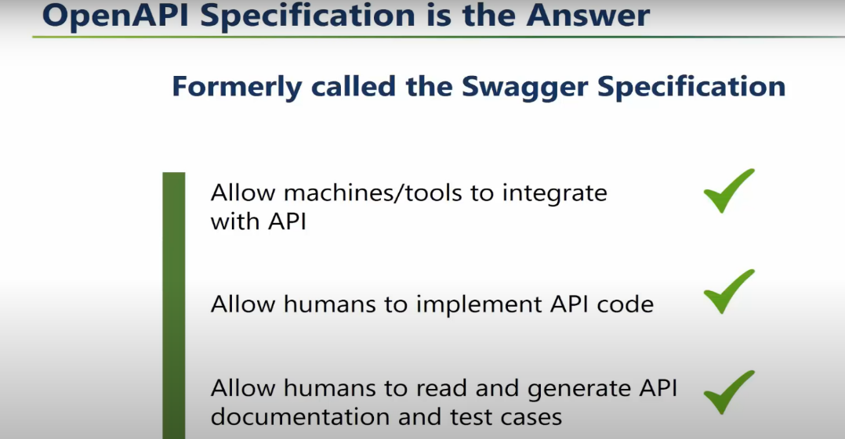

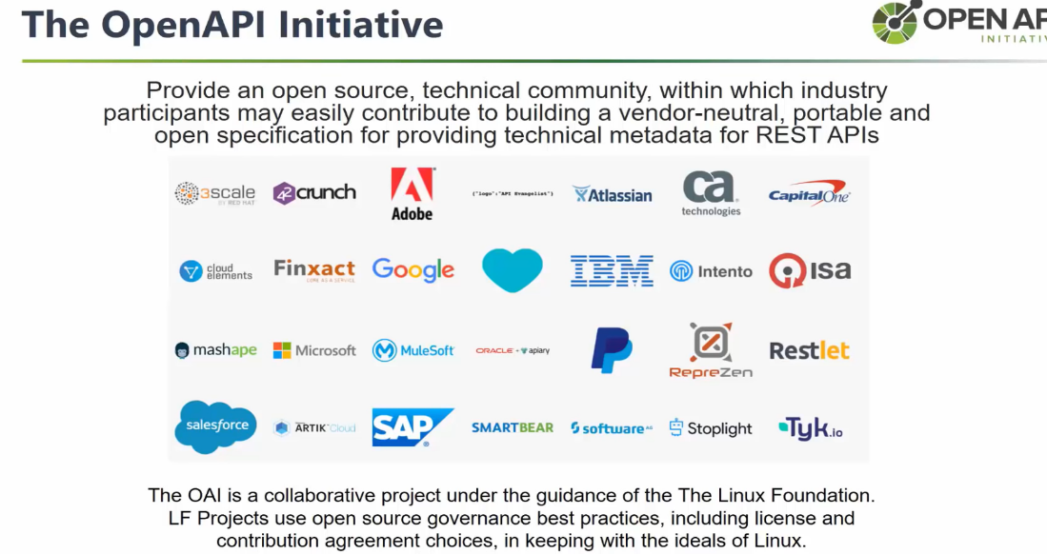

**-------------------------------X------------------------------------------------------------**

**What is difference between Open API 2.0 and Open API 3.0?**

Ans-

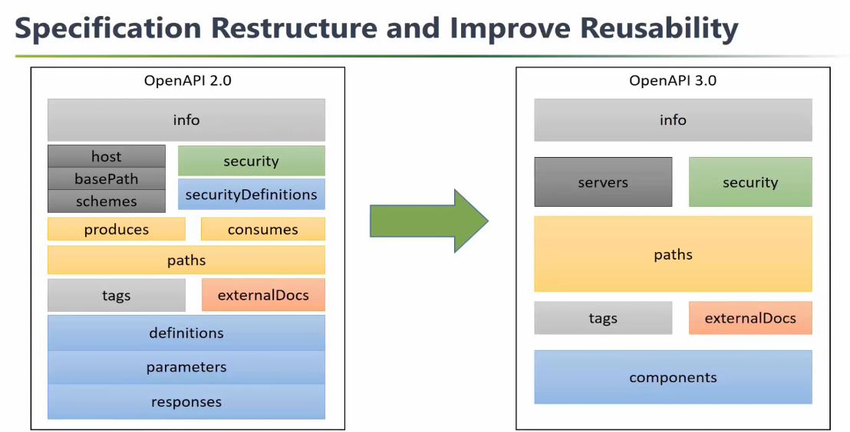

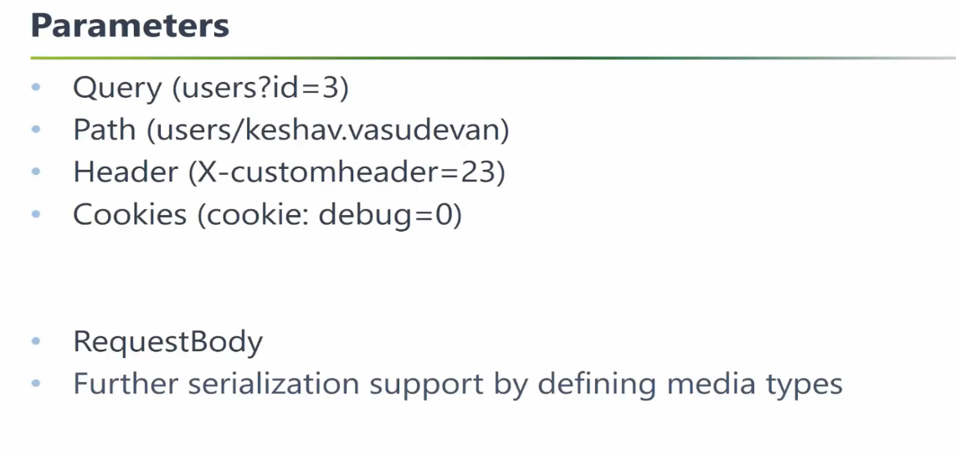

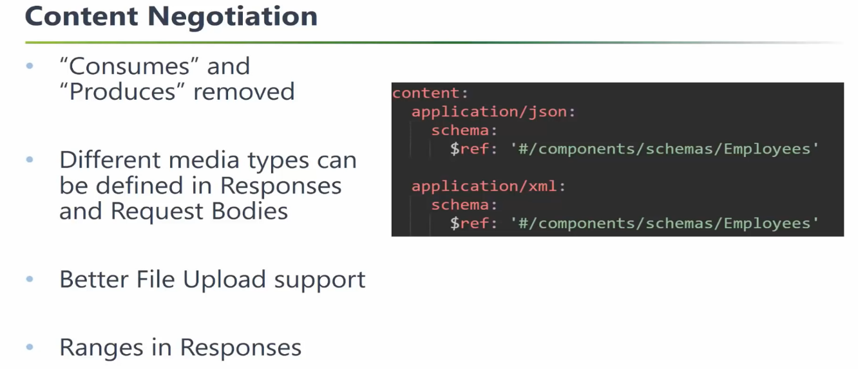

**-----------------------------------X--------------------------------------------------------------**

**Real Life Scenario for Open API?**

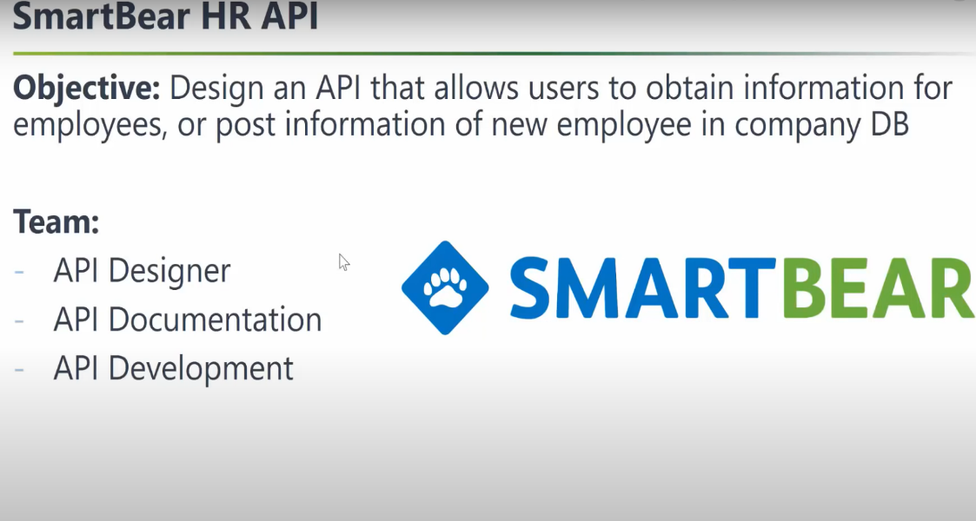

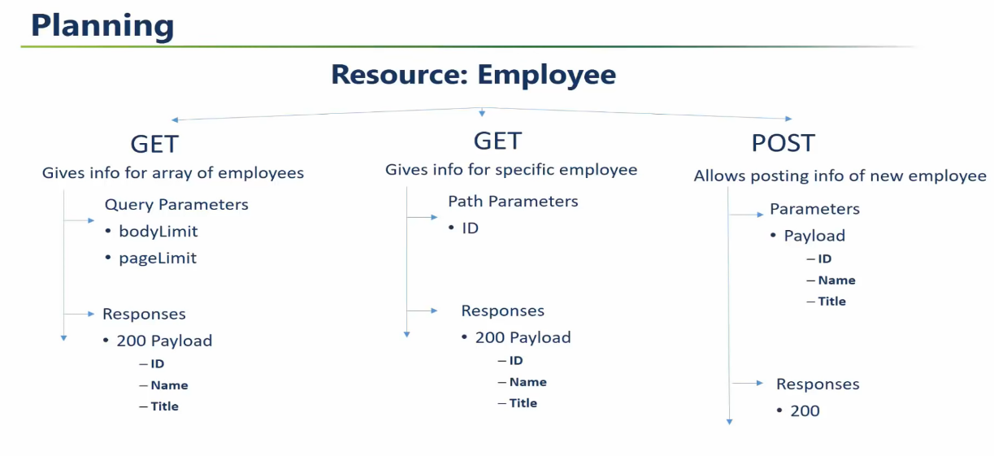

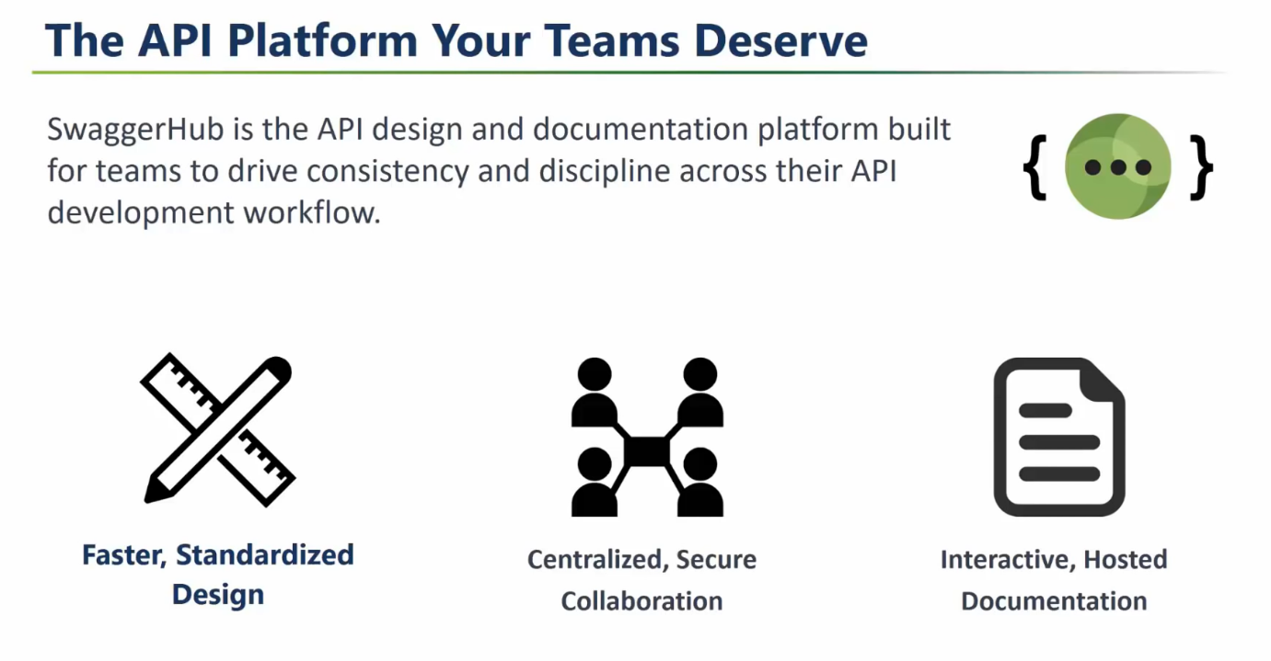

----------------------------X---------------------------------------------------------

**What is CSRF? And Why do we disable it in spring security?**

Ans-

But till now in all our examples we had disabled **CSRF**. **CSRF** stands for **Cross-Site Request Forgery**. It is an attack that forces an end user to execute unwanted actions on a web application in which they are currently authenticated.

--------------------------------X--------------------------------------

**What is the difference between HttpBase authentication and Form Base authentication?**

**Ans-**

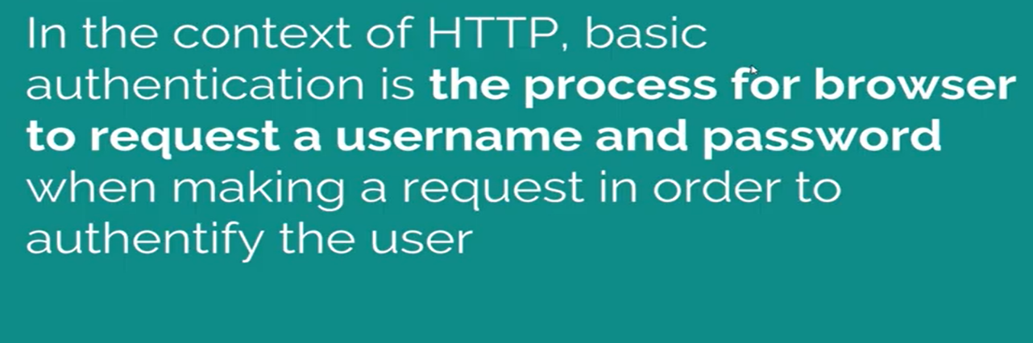

**------------------------------X---------------------------------------------------**

**What are the draw backs of Basic Authentication?**

Ans-

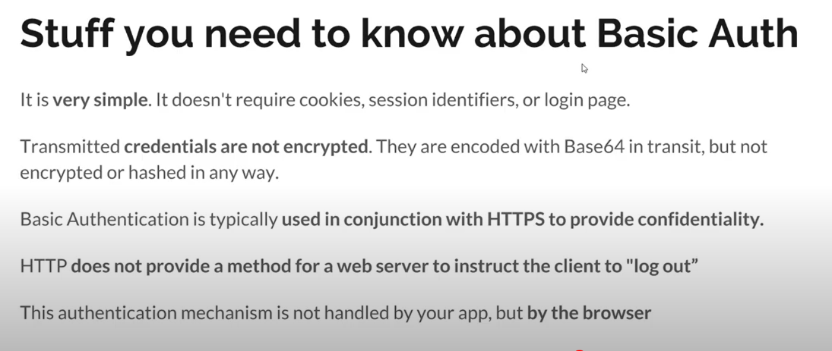

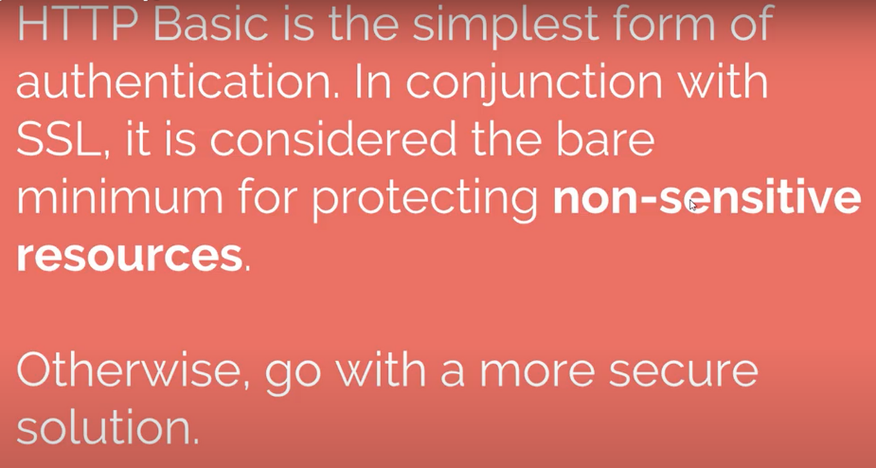

**----------------------------------X-------------------------------------**

**What is Form base authentication?**

Ans-

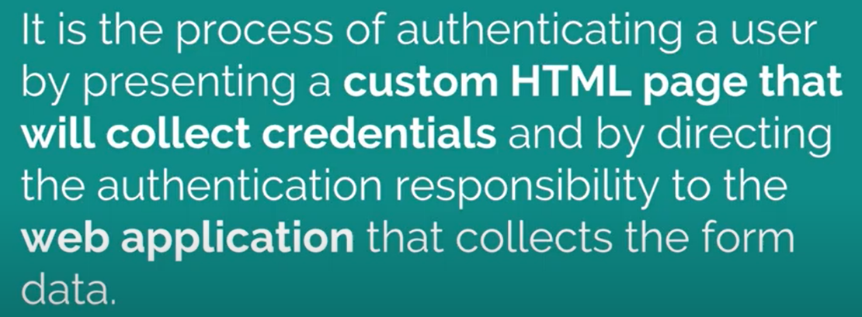

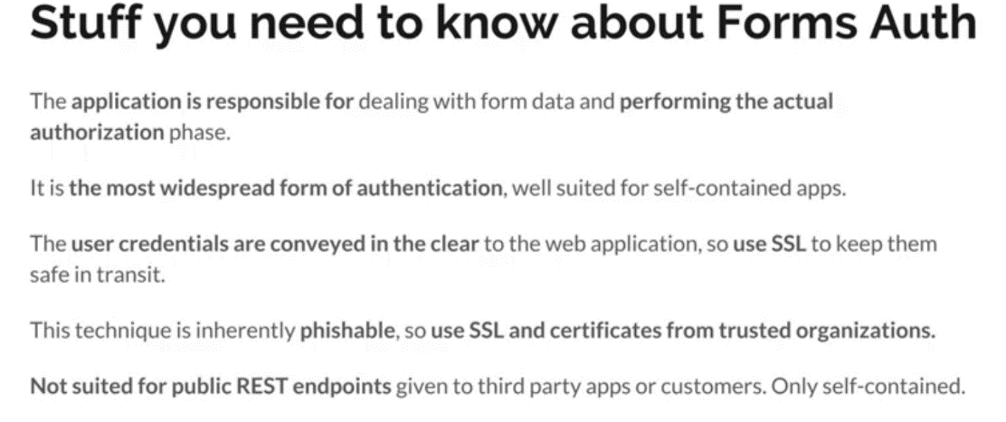

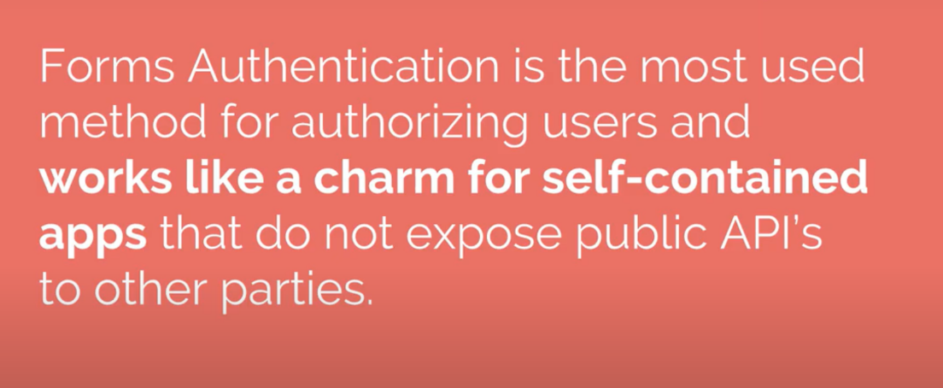

**-------------------------------------------X---------------------------------------------------**

**What is token base authentication JWT?**

Ans-

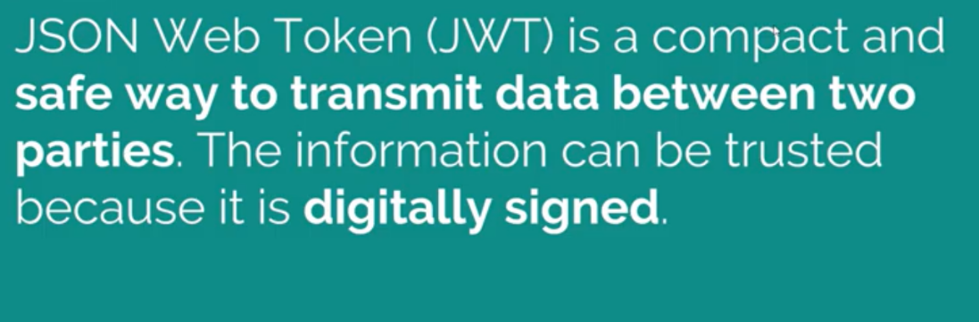

--------------------------------X----------------------------------------------

**How JWT Works?**

Ans-

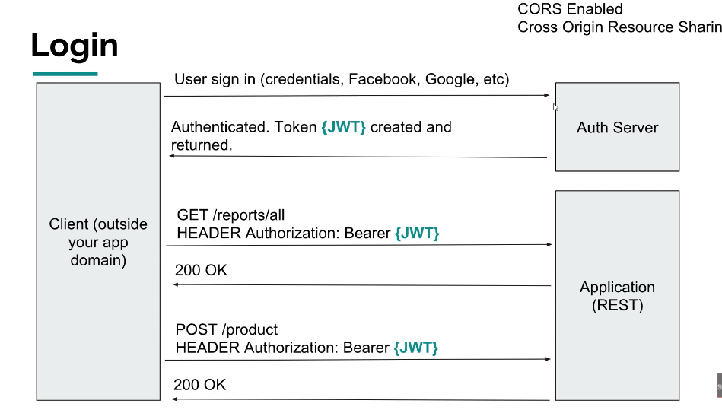

------------------------------------X--------------------------------------------------------

**Explain Structure of JWT?**

Ans-

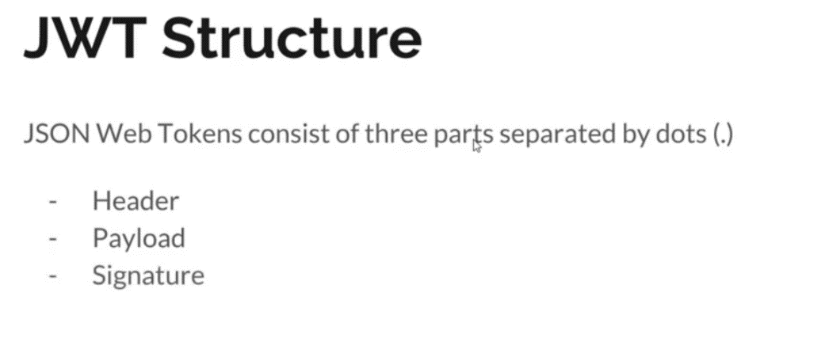

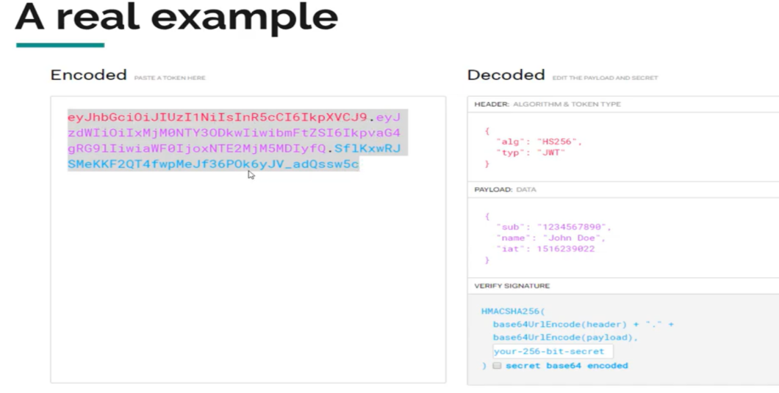

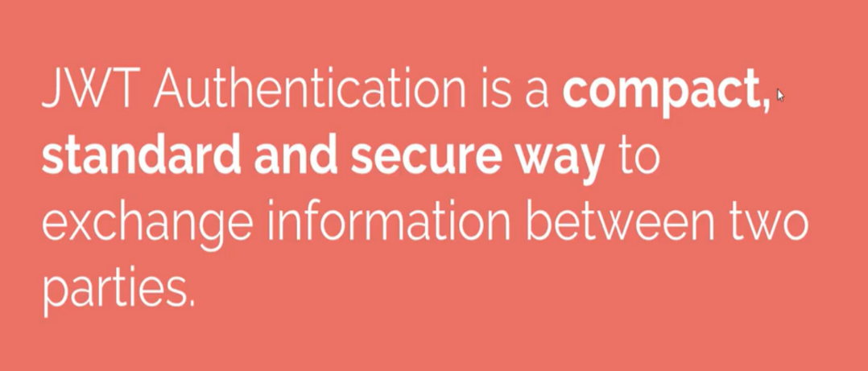

------------------------------------X-------------------------------------------------

What is HTTPS?

Ans-

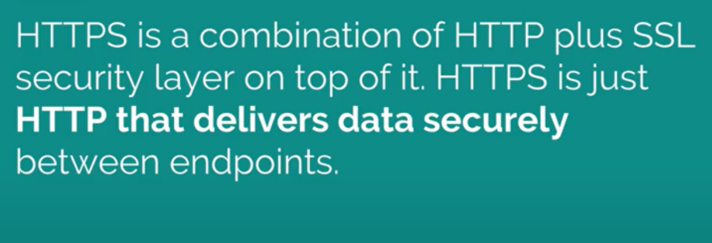

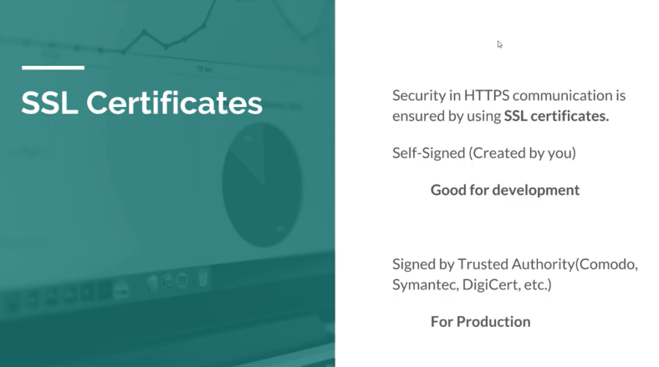

**----------------------------X----------------------------------**

**What is Permission Base Authentication?**

Ans-

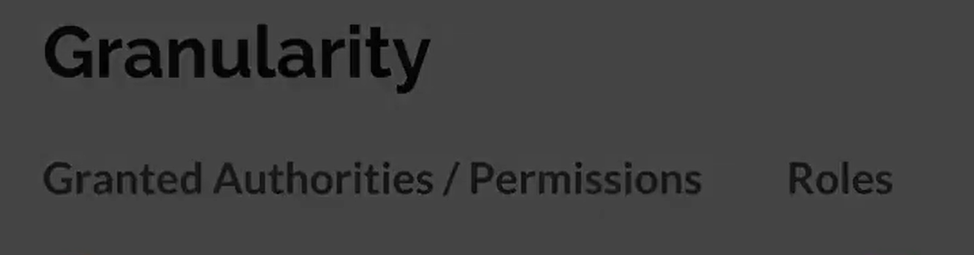

**-------------------------------------------------------X-------------------------------------------------**

**----------------------------------------X------------------------------------------------------------**

**What are the challenges of convention layer architecture DAO where CRUD operations goes in a single layer?**

**Ans-**

* *Domain Model*: The read and write operations are happening over the same domain model. While this is not a problem for a simple domain model like this, it may worsen as the domain model gets complex. **We may need to optimize our domain model and the underlying storage for them to suit the individual needs of the read and write operations. [ Solution-CQRS]**
* *Persistence*: The persistence we have for our domain objects stores only the latest state of the domain model. While this is sufficient for most situations, it makes some tasks challenging. **For instance, if we have to perform a historical audit of how the domain object has changed state, it's not possible here**. We have to supplement our solution with some audit logs to achieve this. [Solution –Event Sourcing]

**------------------------------------------------X----------------------------------------------------------**

**What is CQRS?**

**Ans:-**

* CQRS is **about segregating the command and query side of the application architecture**.
* CQRS is based on the Command Query Separation (CQS) principle which was suggested by Bertrand Meyer.
* CQS suggests that we divide the operations on domain objects into two distinct categories: Queries and Commands:
* **Queries return a result and do not change the observable state** of a system.
* **Commands change the state of the system but do not necessarily return a value**.

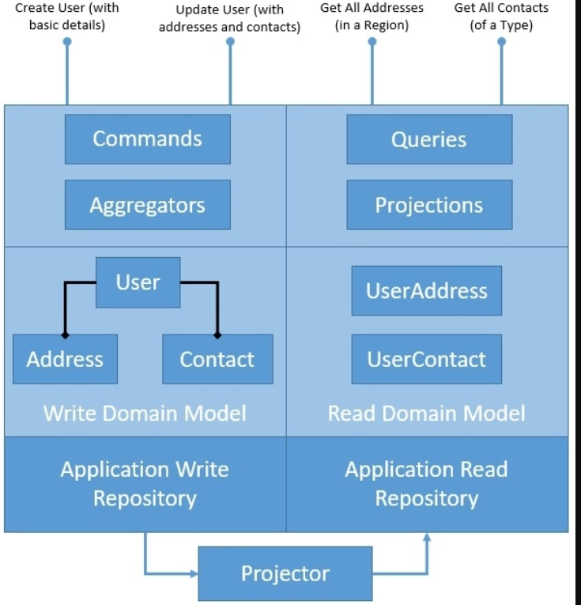

**------------------------------------------X---------------------------------------------------------**

**What is Aggregation and Projection In CQRS?**

**Ans-**

* Aggregate is **a pattern described in Domain-Driven Design (DDD) that logically groups different entities by binding entities to an aggregate root**.
* The aggregate pattern provides transactional consistency between the entities.
* CQRS naturally benefits from the aggregate pattern, which groups the write domain model, providing transactional guarantees. Aggregates normally hold a cached state for better performance but can work perfectly without it.

Projection/Projector:

* Projection is another important pattern which greatly benefits CQRS. Projection **essentially means representing domain objects in different shapes and structures**.
* These projections of original data are read-only and highly optimized to provide an enhanced read experience. We may again decide to cache projections for better performance, but that's not a necessity.

--------------------------------X-----------------------------------------

**What is Event Sourcing?**

**Ans-**

* Event Sourcing **gives us a new way of persisting application state as an ordered sequence of events**.
* We can selectively query these events and reconstruct the state of the application at any point in time.
* Of course, to make this work, we need to reimage every change to the state of the application as events:

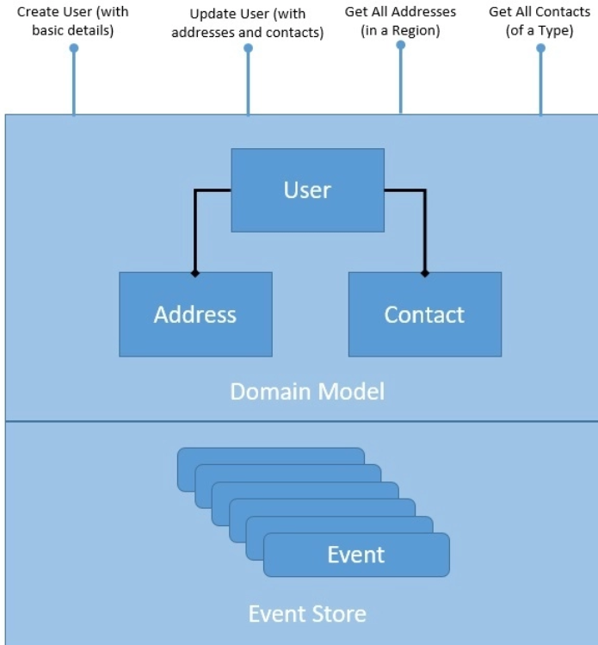

**----------------------------------------X--------------------------------------------**

**What is Event Sourcing?**

**Ans-**

* In CQRS terms, read and write operations are referred to as, respectively, query and command.
* In general, CRUD systems can be all logically divided into command and query sub-systems.
* CQRS is best to apply on the CRUD applications that **(a)** require to use a different model to update information than the model they use to read nformation,
* **(b)** require time-consuming queries for reads, and **(c)** have considerably higher reads than writes. Otherwise, [increased complexity](https://martinfowler.com/bliki/CQRS.html), as a consequence.
* In CQRS case, we need different models for read and write and can probably expect a higher number of reads than writes (every time the page is loaded a read request is sent to the backend.
* At its heart, CQRS is all about segregating command and query operations.
* To do that, we split up the backend into two microservices, command and query, so that they can be independently scaled and maintained.
* Moreover, in order to support different read and write models and ensure loose coupling, we decentralise the database and keep each microservice’s persistent data private to that service and accessible only via its APIs.
* As the number of users grow and the amount of data increases, both microservices will be able to satisfy different storage and schema requirements.

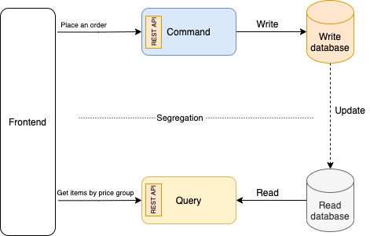

## **Applying Event Sourcing-**So even if we successfully segregated the command and query operations. How , we are going to reliably update the read database as information is being written into the write database.

## For example, as soon as a user places a new order for an item, in addition to undertaking the write responsibilities, the backend needs to simultaneously identify the item as one of cheap, affordable, or expensive and store it in the read database.

## One option is to call the query API from the command microservice and synchronously update the read database.

## This solution, however, introduces tight coupling and compromises reliability. If the query microservice is down, any incoming data will be lost.

## A much better option is to apply **Event Sourcing**. Event sourcing involves two steps: **(1)** modeling the state changes made by an application as a set of immutable events, and **(2)** modeling the state changes as responses to the events.

## In simple words, event sourcing decouples the application change from the record of that change and uses the latter as the source of truth.

## **Event sourcing** will allow us to asynchronously (and reliably) update the read database to reflect changes to the write database.

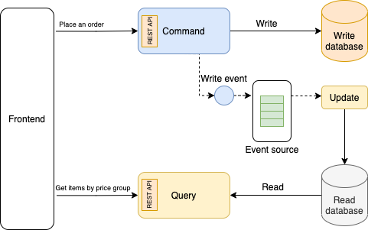

* **CQRS with Event Sourcing**

# CQRS using Apache Kafka Streams- Kafka is already one of the best options for Event Sourcing. You can write events to Kafka (write model), read them back, and then push them into a database or a different topic (read model).

# In doing so, Kafka maps the read model onto the write model asynchronously, decoupling the two. Kafka is, therefore, a natural choice for implementing CQRS.

# In an event sourcing architecture, events are the first class citizens. This is different from traditional architectures, in which database is the primary source of truth. The [stream-table duality](https://towardsdatascience.com/apache-kafka-streams-and-tables-the-stream-table-duality-ee904251a7e) concept, coupled with fault tolerance and high availability of Kafka, enable us to replace database with events as the primary source of data.

# What distinguishes an event-sourced view from a typical database or cache is that, while it can represent data in any form required, its data is sourced directly from the events log and can be regenerated at any time.

# Writes go into Kafka on the command side and generate a stream of events. We can transform the stream in a way that suits our use case, typically using Kafka Streams, then materialise it as a [precomputed query](https://www.confluent.io/blog/unifying-stream-processing-and-interactive-queries-in-apache-kafka/).

# A materialised view in Kafka is a table that contains the results of some predefined query. The view gets updated every time any of the underlying tables change. But unlike with materialized views in a relational database, the underlying events are decoupled from the view. This means ****(a)**** they can be scaled independently, and ****(b)**** the writing process doesn’t have to wait for the view to be computed before it returns.

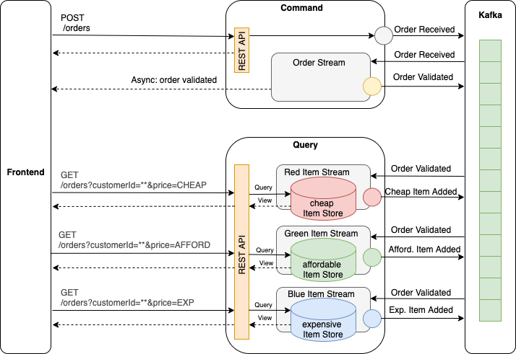

**CQRS pattern using Kafka:** Events are the source of truth. Materialized views provide a pre-computed in-memory cache for the query microservice.

**-----------------------------------------X------------------------------------------------------------------**

**What is Transaction in Miroservice?**

**Ans-**

* In programming, we refer to a transaction as **a group of related actions that need to be performed as a single action**.
* In other words, a transaction is a logical unit of work whose effect is visible outside the transaction either in entirety or not at all.
* We require this to ensure data integrity in our applications.
* A typical requirement in event-based architecture is to update the local database and produce an event for consumption by other services:

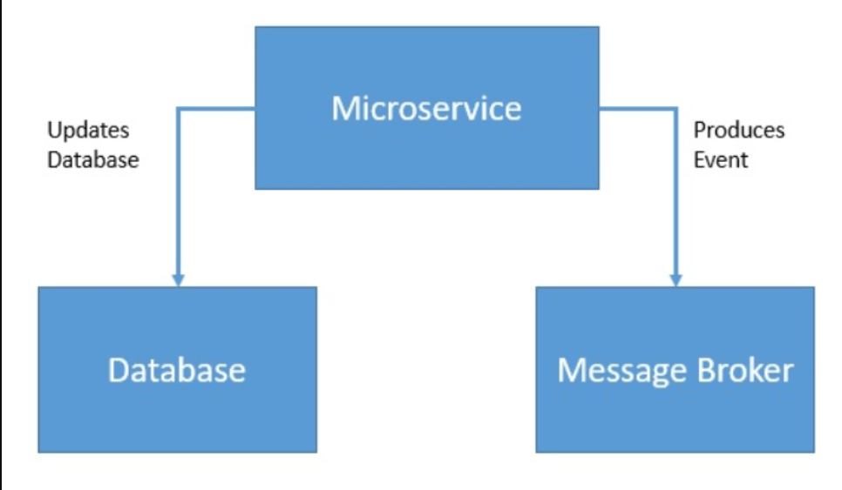

* Here, we'd like these two operations to either happen together or not happen at all.
* We can achieve this by wrapping these operations into a single transaction:

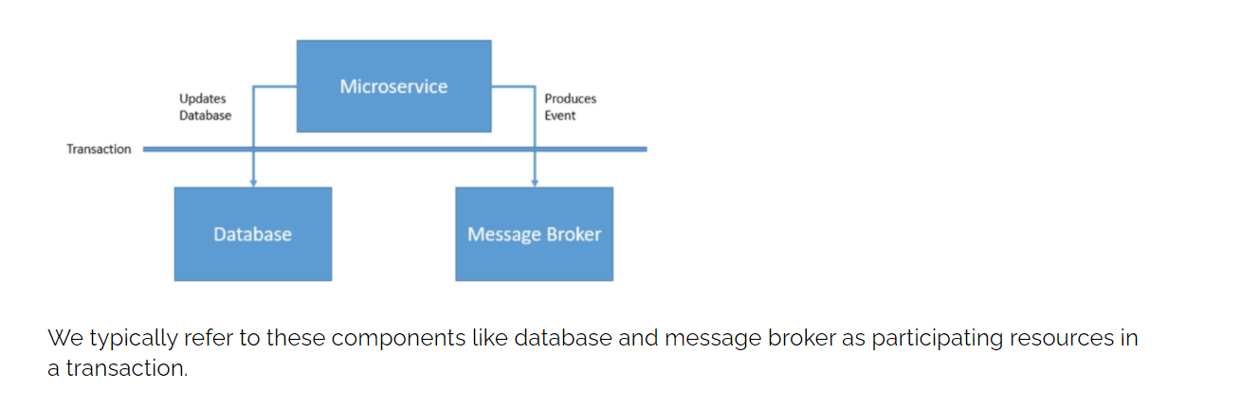

**--------------------------------------X----------------------------------------------**

**What is Saga Pattern?**

**Ans-**

* The [saga interaction pattern](https://www.baeldung.com/cs/saga-pattern-microservices) **attempts to break a long-running business process to multiple small and related business actions** and interactions.
* Further, it coordinates the whole process by managing based on messages and timeouts. This was [first defined back in 1987](http://www.cs.cornell.edu/andru/cs711/2002fa/reading/sagas.pdf) by Hector Garcia-Molina and Kenneth Salem.

Let's see how Saga decomposes a business process:

[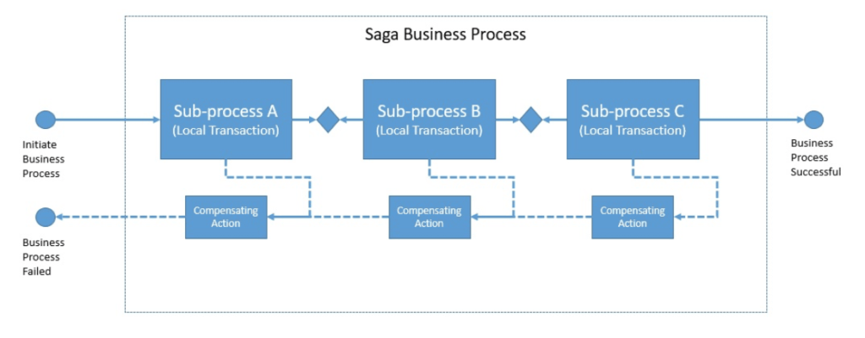](https://www.baeldung.com/wp-content/uploads/2020/04/Screenshot-2020-04-25-at-06.54.45.png)

* you have applied the [Database per Service](https://microservices.io/patterns/data/database-per-service.html) pattern. Each service has its own database. Some business transactions, however, span multiple service so you need a mechanism to implement transactions that span services.
* For example, let’s imagine that you are building an e-commerce store where customers have a credit limit.
* The application must ensure that a new order will not exceed the customer’s credit limit. Since Orders and Customers are in different databases owned by different services the application cannot simply use a local ACID transaction.
* implement each business transaction that spans multiple services is a saga.
* A saga is a sequence of local transactions.
* Each local transaction updates the database and publishes a message or event to trigger the next local transaction in the saga.
* If a local transaction fails because it violates a business rule then the saga executes a series of compensating transactions that undo the changes that were made by the preceding local transactions.

